<https://www.youtube.com/watch?v=8b1JEDvenQU&list=PLblh5JKOoLUICTaGLRoHQDuF_7q2GfuJF&index=60>



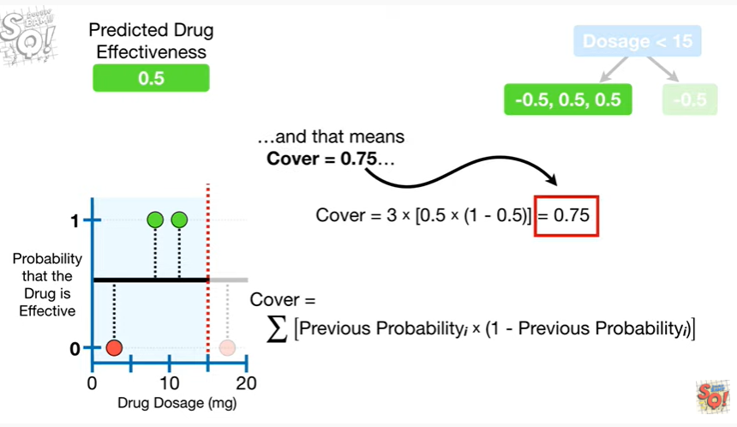

and that means cover equals 0.75

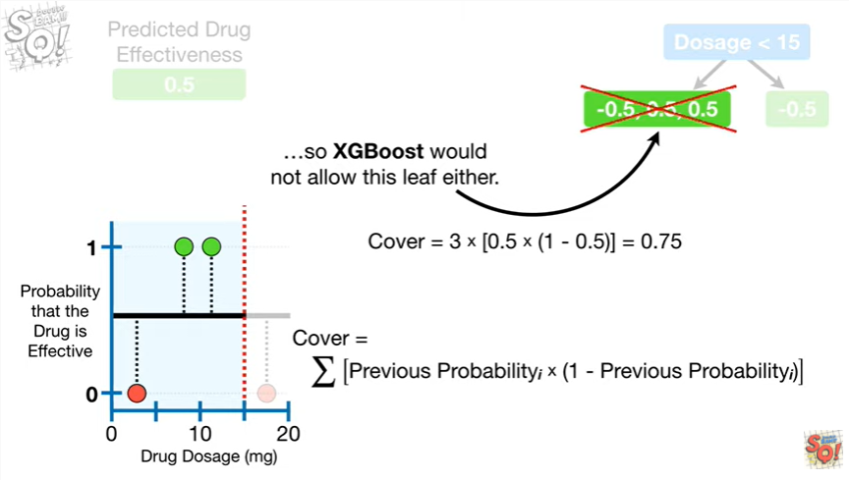

so XGBoost would not allow this leaf either.

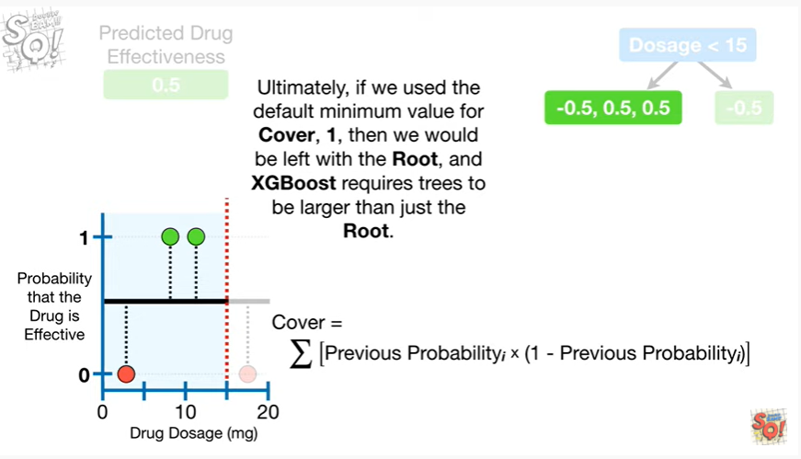

Ultimately, if we use the default minimum value for cover, 1, then we would be left with the roo,t and XGBoost requires trees to be larger than just the root.

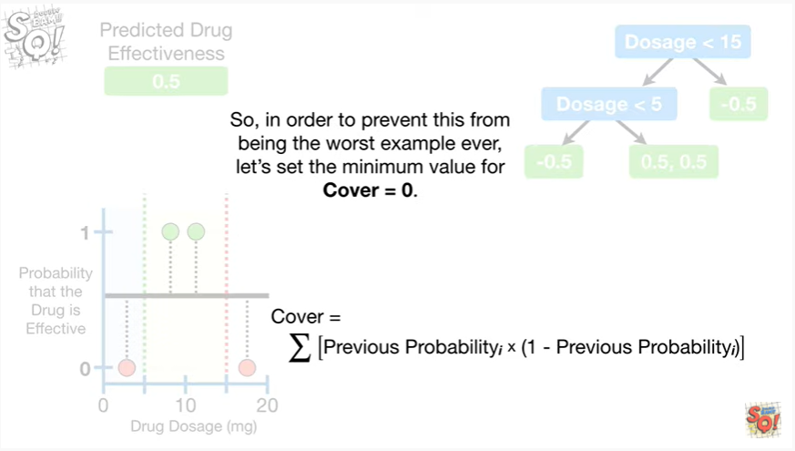

So, in order to prevent this from being the worst example ever, let's set the minimum value for cover equal to zero.

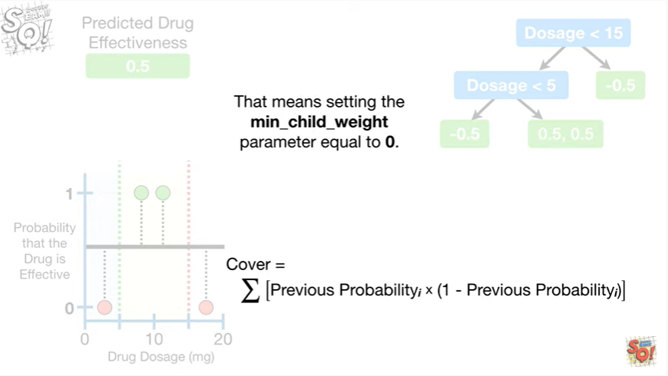

And that means setting the min_child_weight parameter equal to zero.

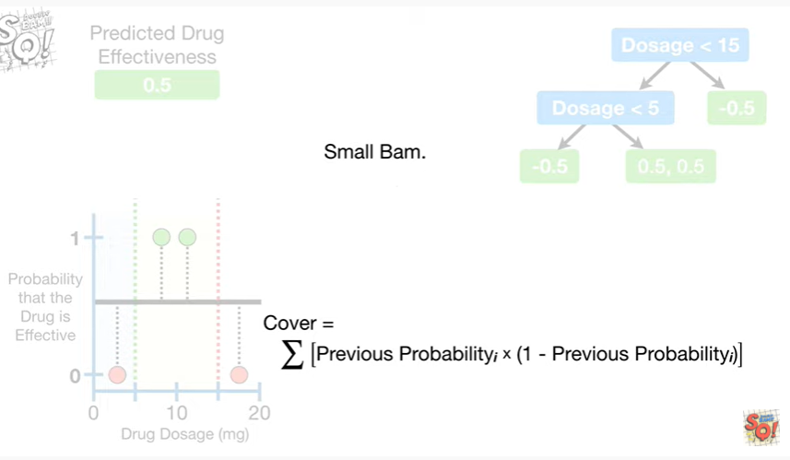

Small Bam.

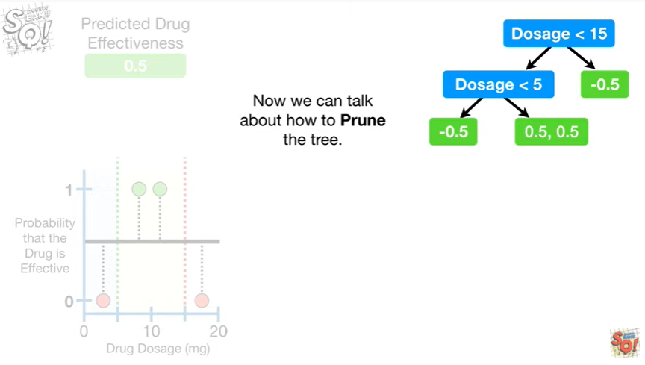

Now we can talk about how to prune the tree.

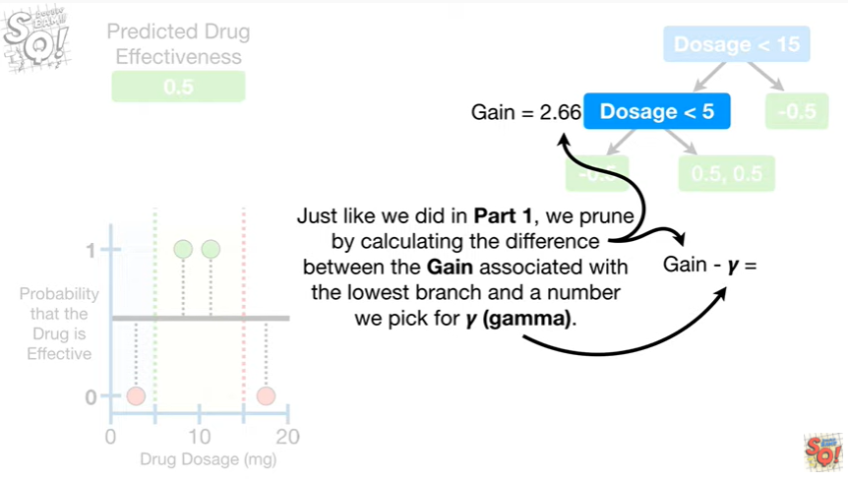

Just like we did in part one, we prune by calculating the difference between the gain associated with the lowest branch and a number we pick for gamma.

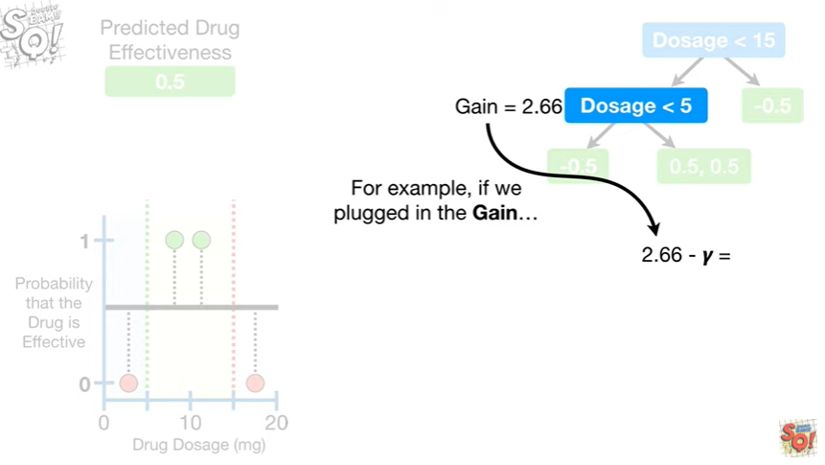

For example, if we plugged in the gain

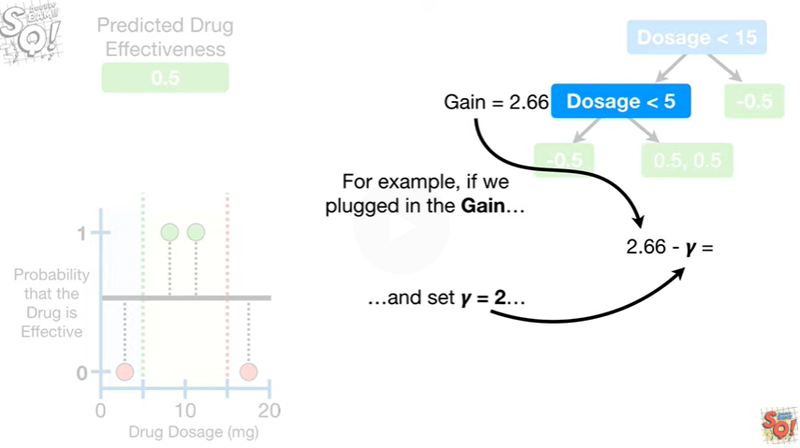

and Set gamma equal to two

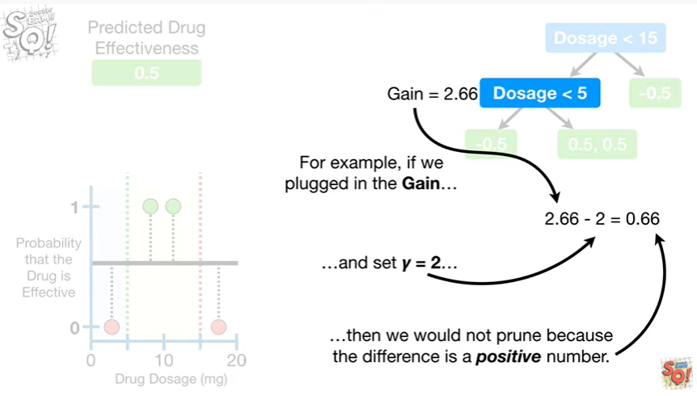

then we would not prune because the difference is a positive number.

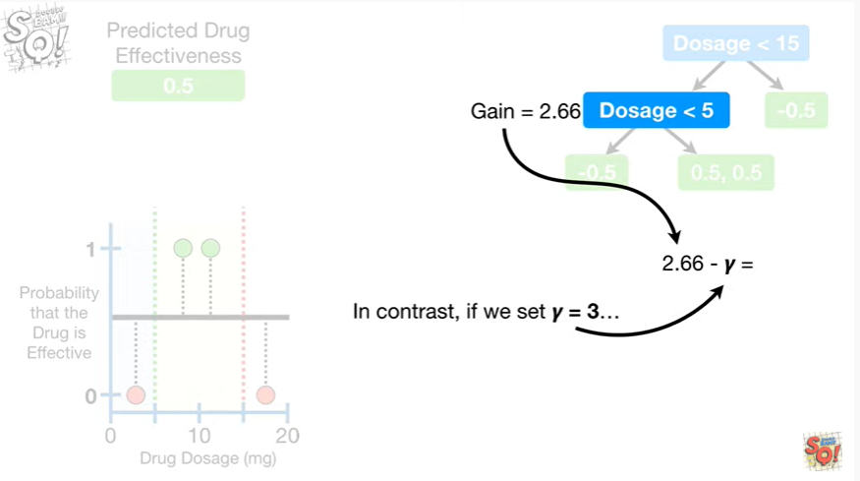

In contrast, if we set gamma equal to three

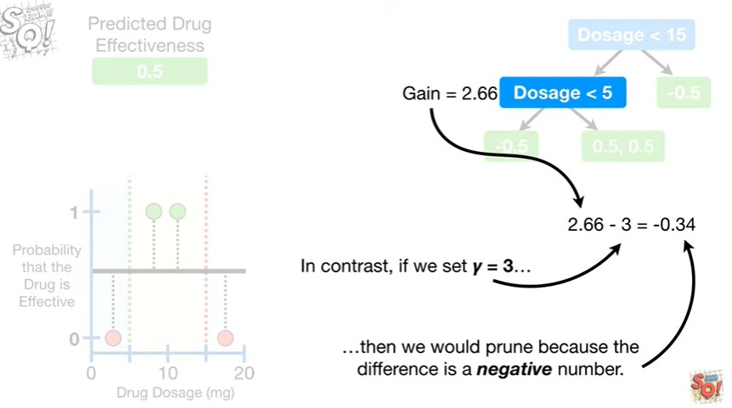

then we would prune because the difference is a negative number.

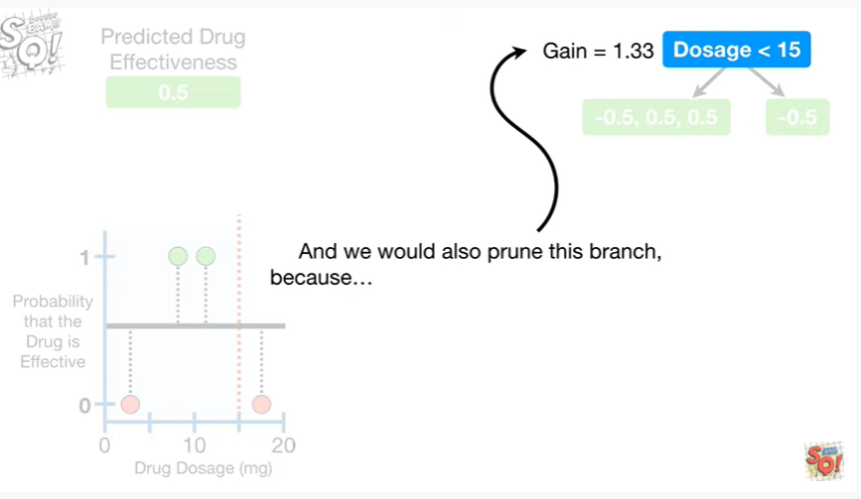

And we would also prune this branch because

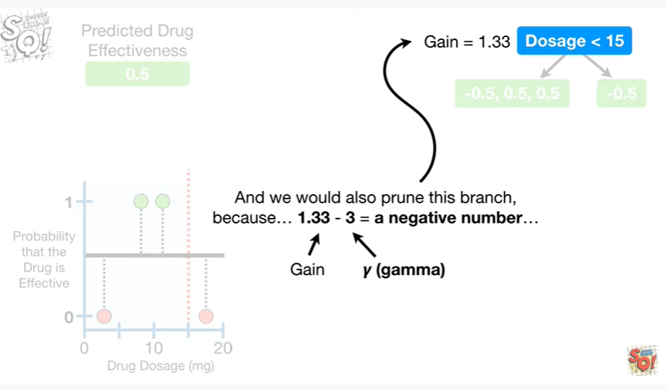

1.3 3 minus 3 equals a negative number

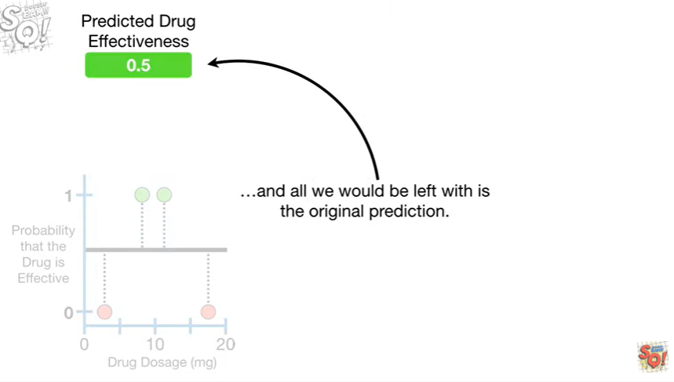

and all we would be left with is the original prediction.

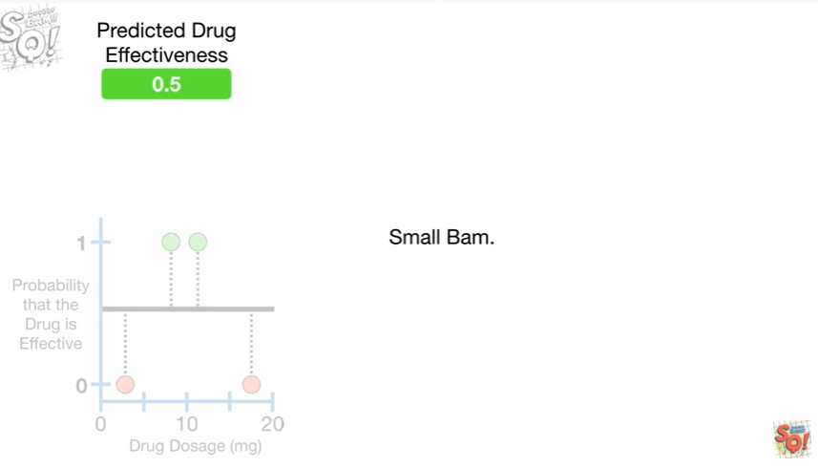

Small Bam.

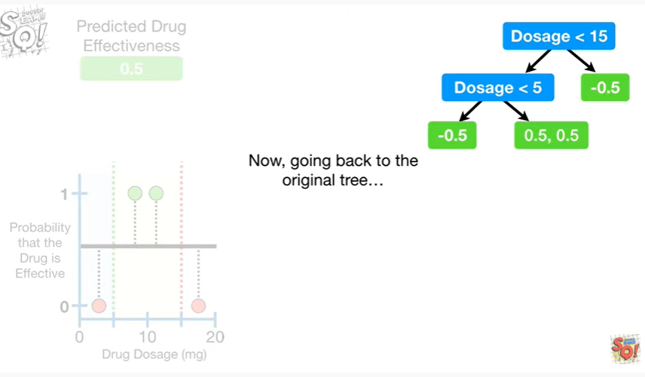

Now, going back to the original tree

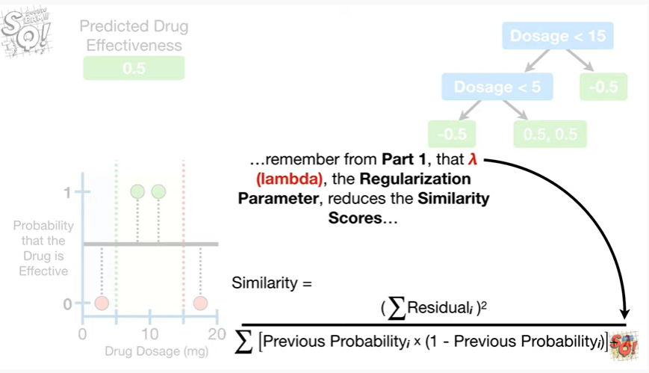

remember from part 1, that lambda the regularization parameter, reduces the similarity scores

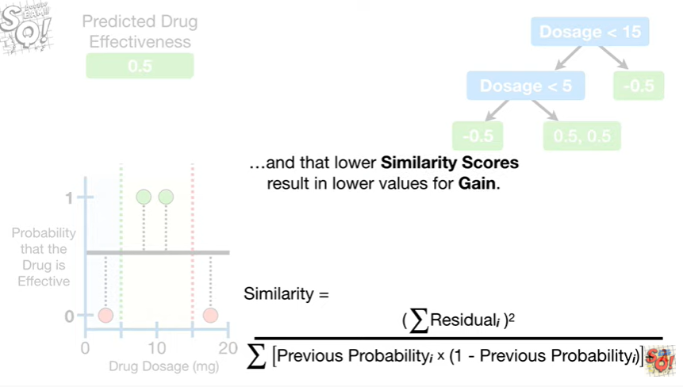

and that lower similarity scores result in lower values for gain.

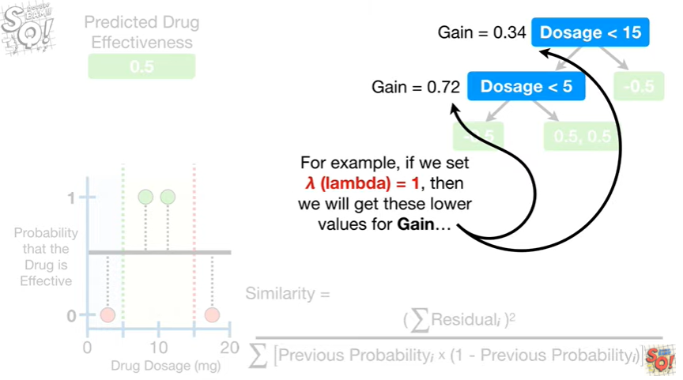

For example if we set lambda equal to 1, then we would get these lower values for gain

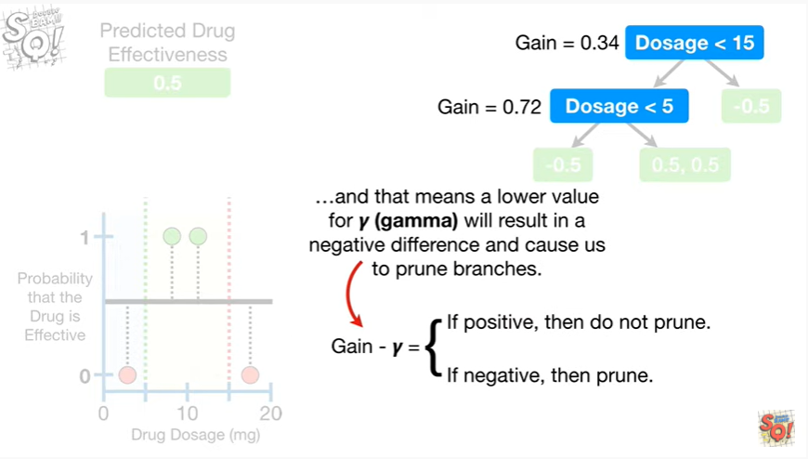

and that means a lower value for gamma will result in a negative difference and cause us to prune branches.

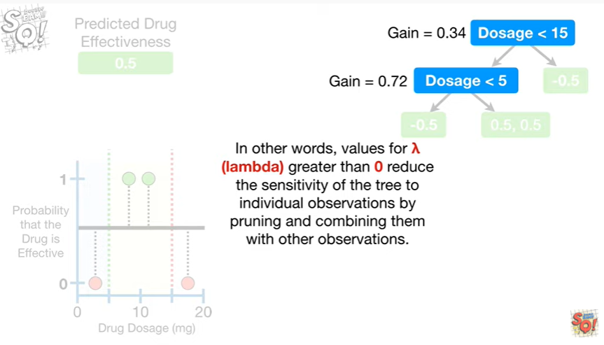

In other words, values for lambda greater than zero reduce the sensitivity of the tree to individual observations by pruning and combining them with other observations.

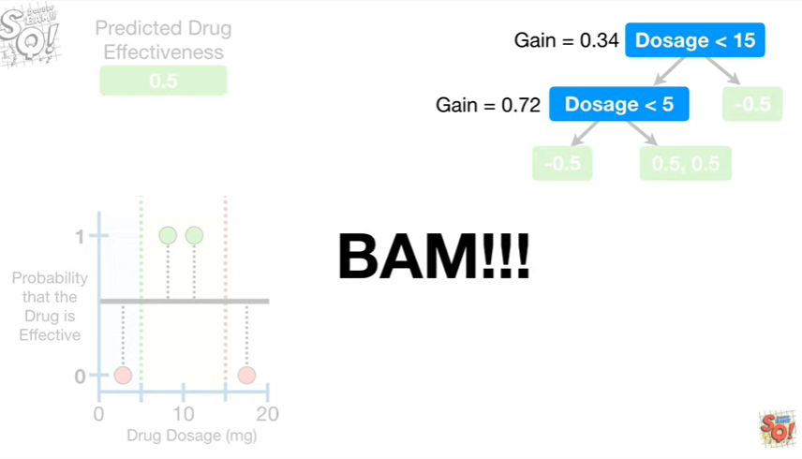

BAM !!!

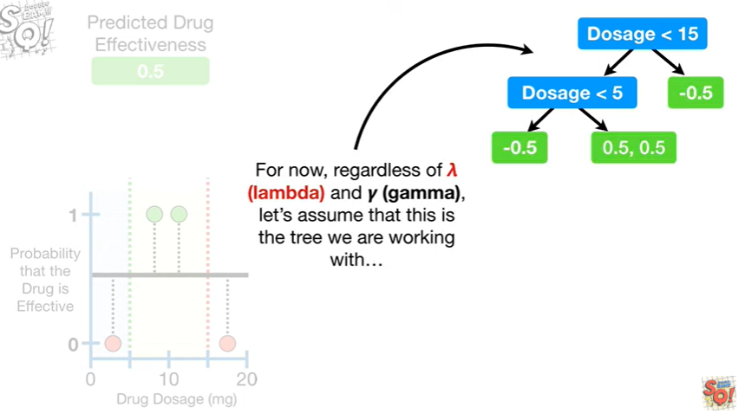

For now, regardless of lambda and gamma let's assume that this is the tree we are working with

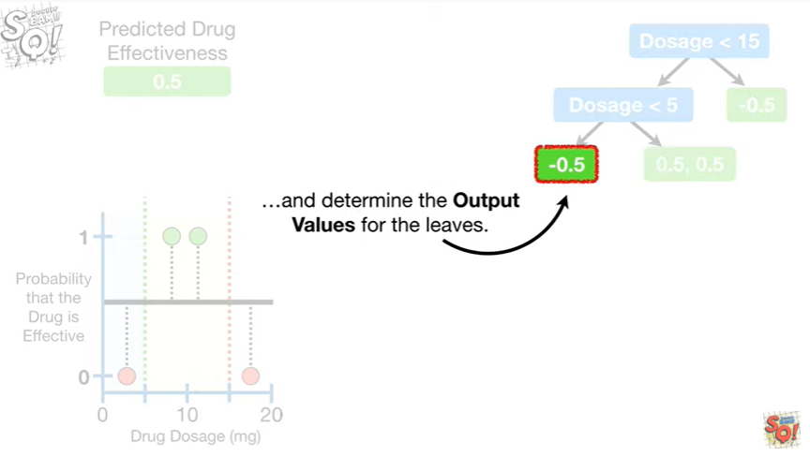

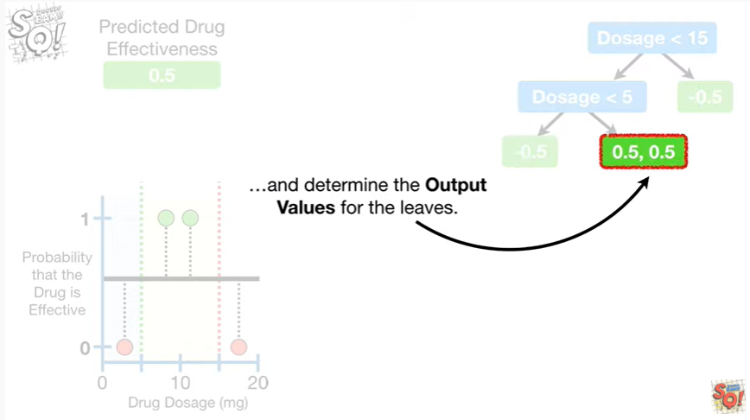

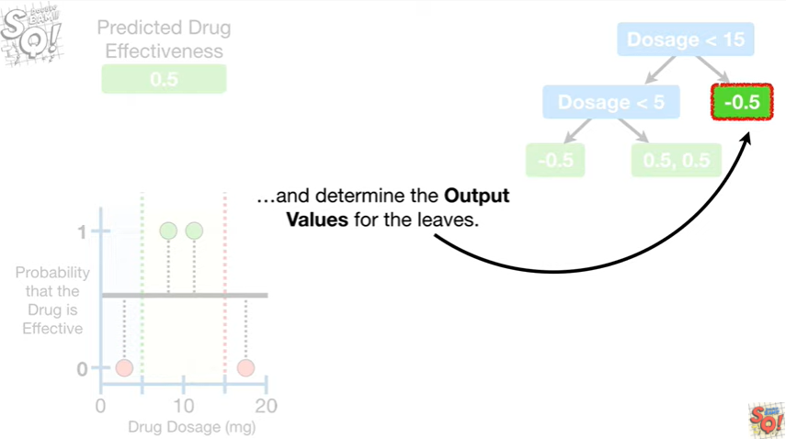

and determine the output values for the leaves.

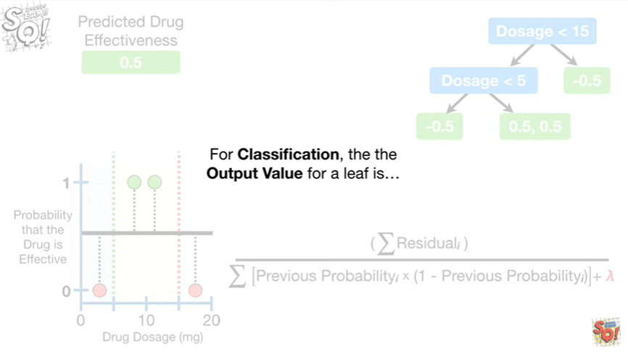

For classification, the output value for a leaf is

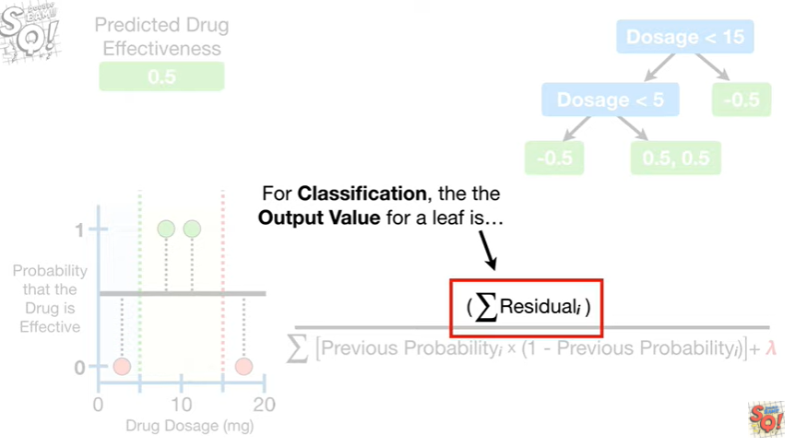

the sum of the residuals

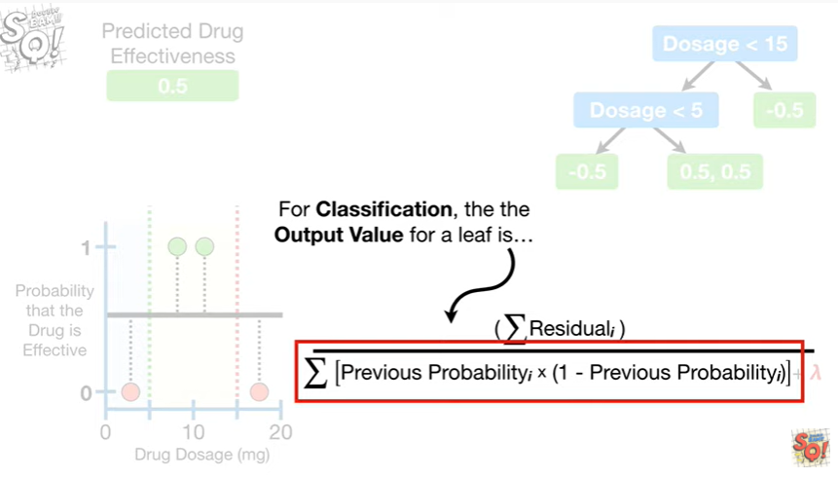

divided by the sum of the previous probability times 1 minus the previous probability for each residual in the leaf

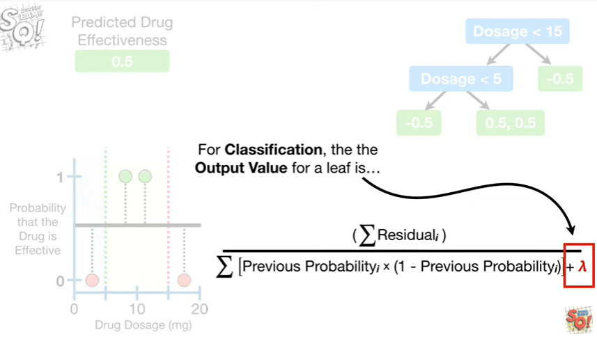

plus lambda.

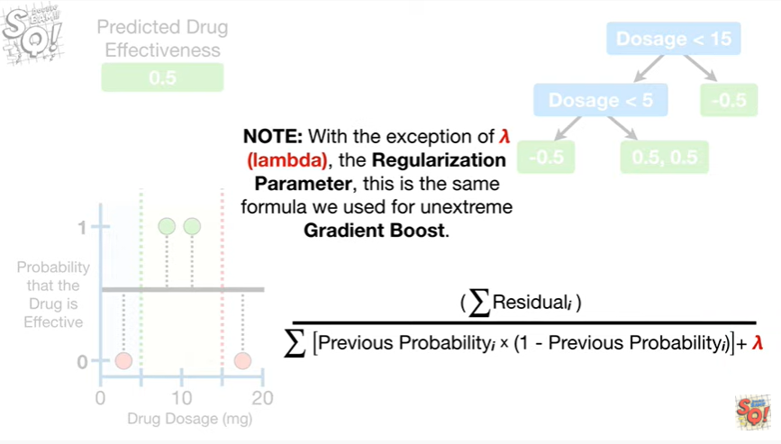

Note : with the exception of lambda, the regularization parameter, this is the same formula we used for unextrem gradient boost.

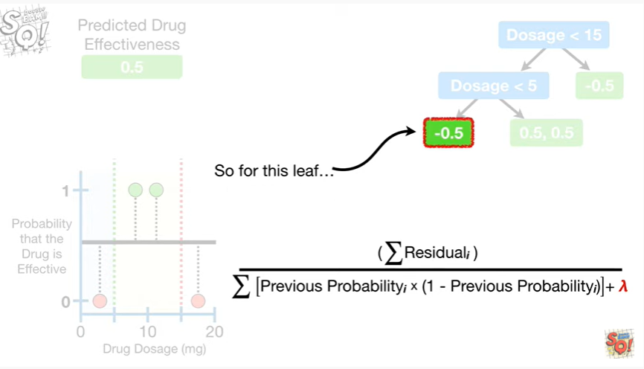

So for this leaf

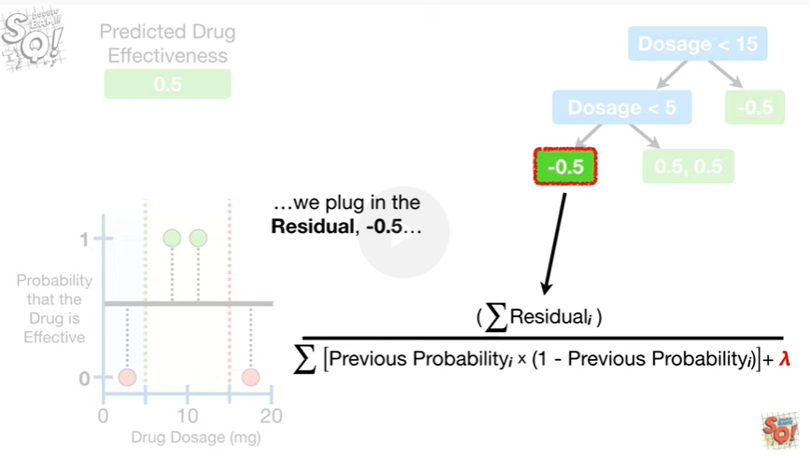

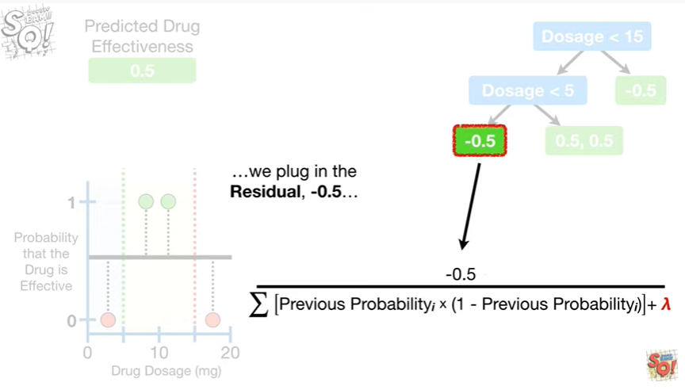

we plug in the residual negative 0.5

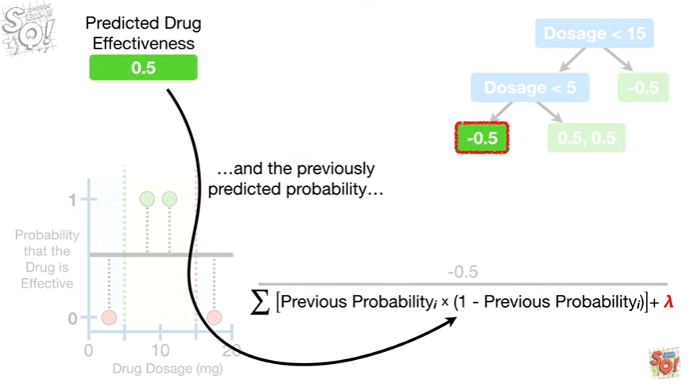

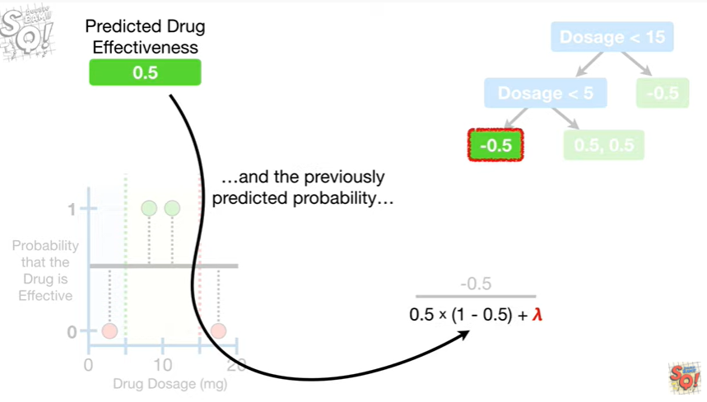

and the previously predicted probability

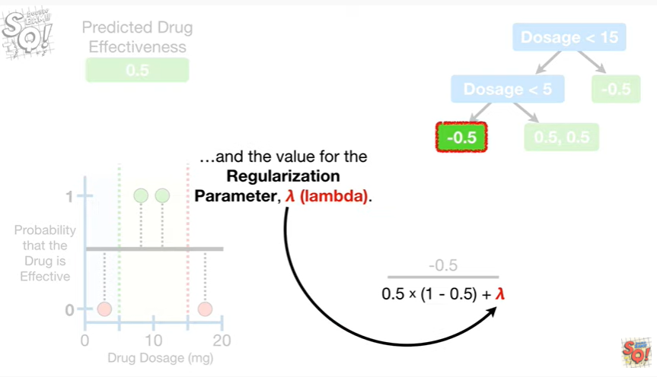

and the value for the regularization parameter, lambda.

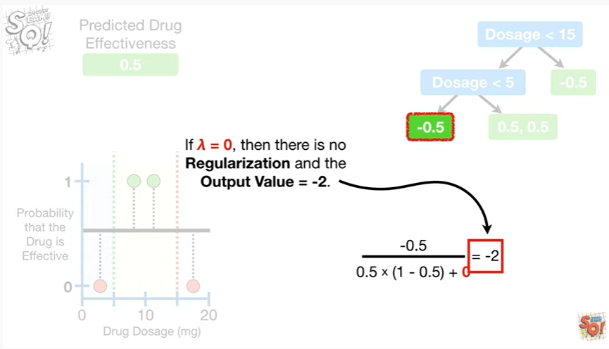

If lambda equals zero then there is no regularization and the output value equals negative two.

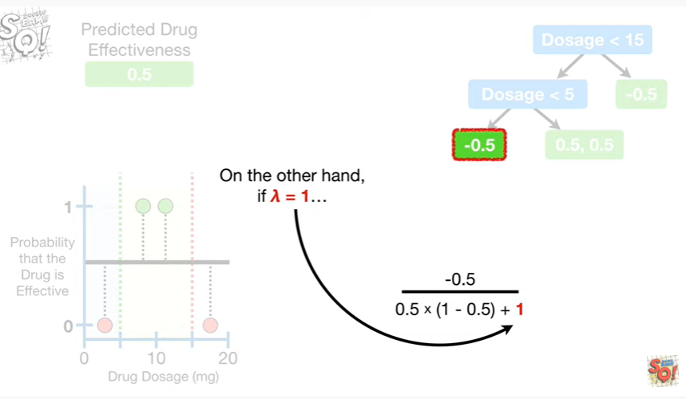

On the other hand, if lambda equals 1

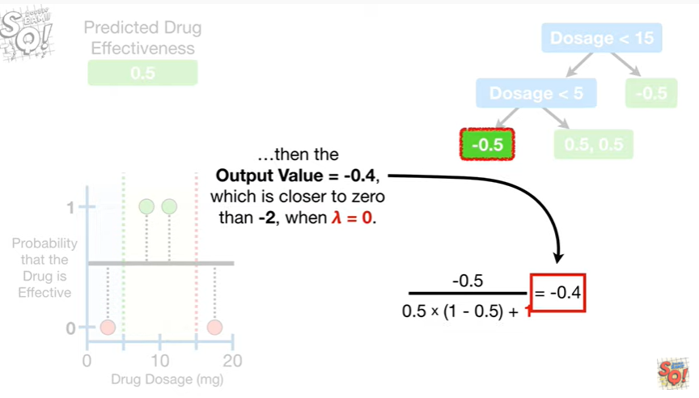

then the output value equals negative 0.4, which is closer to zero than negative two, when lambda equals zero.

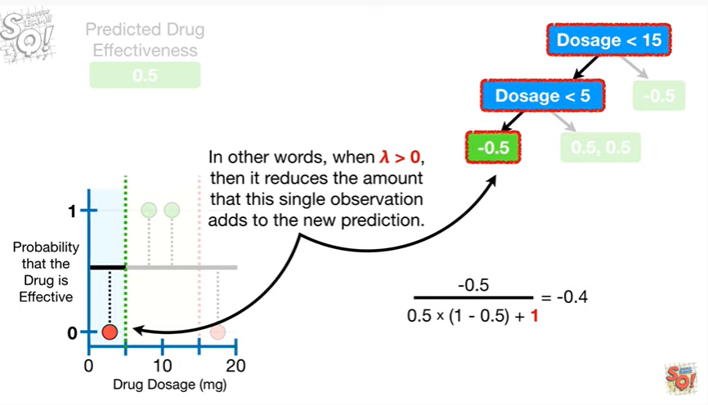

In other words, when lambda is greater than zero, then it reduces the amount that this single observation adds to the new prediction.

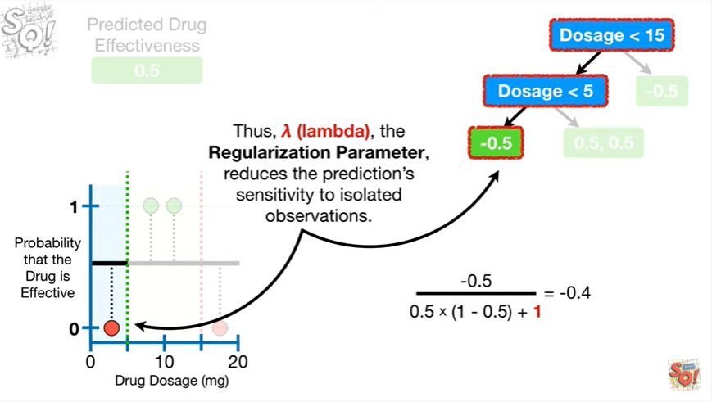

Thus, lambda the regularization parameter reduces the prediction sensitivity to isolated observations.

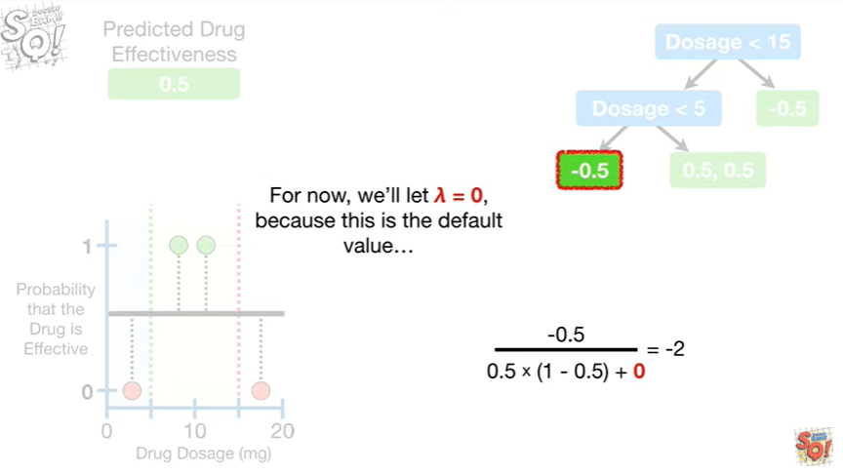

For now, we'll let lambda equal zero because this is the default value

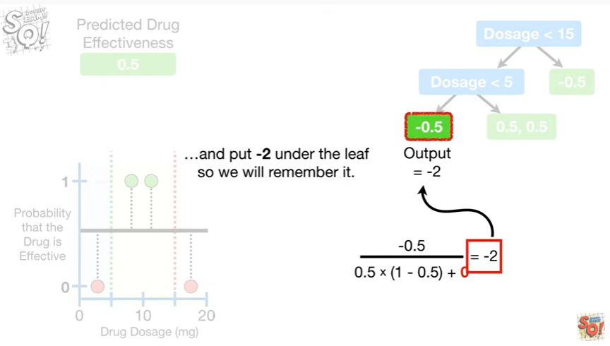

and put negative two under the leaf, so we will remember it.

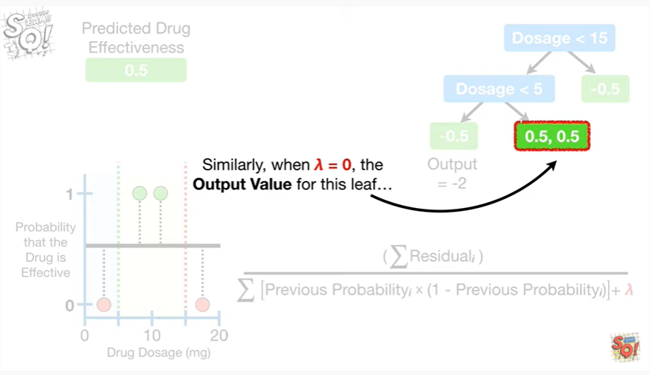

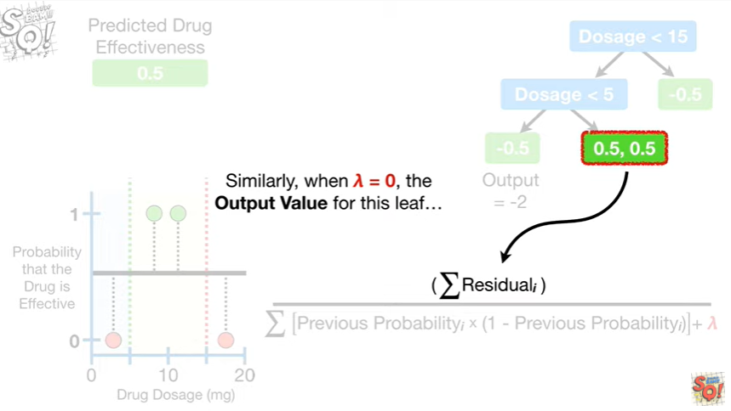

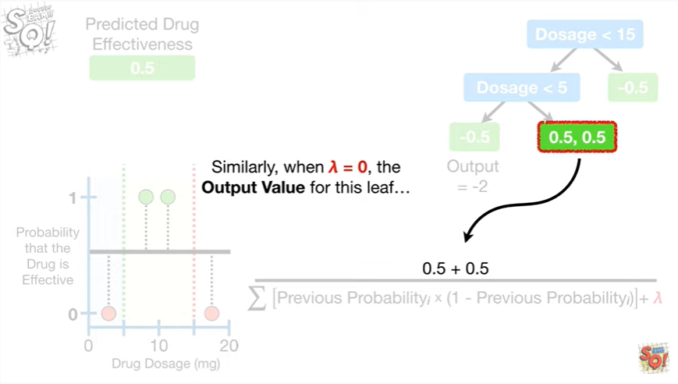

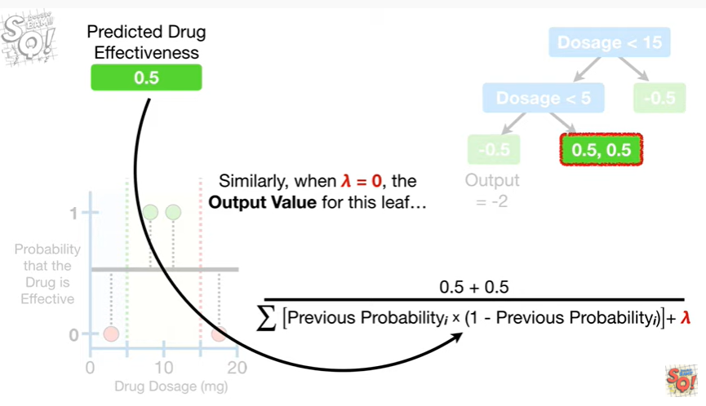

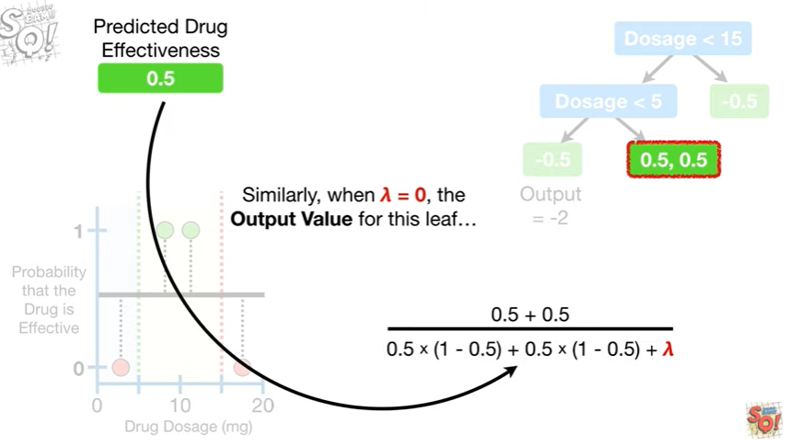

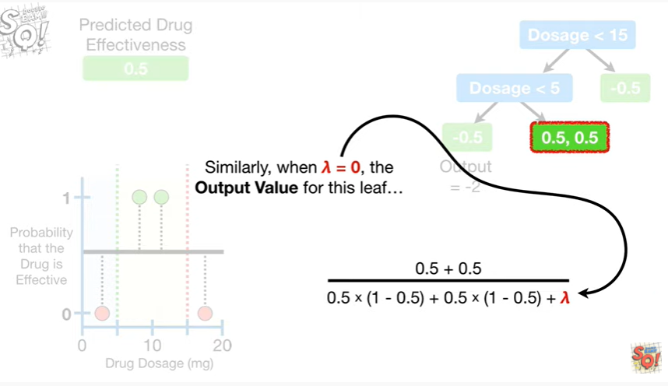

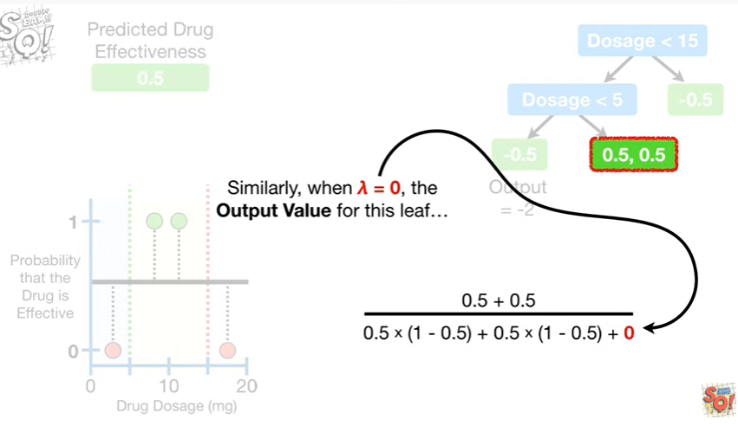

Similarly when lambda equals zero the output value for this leaf

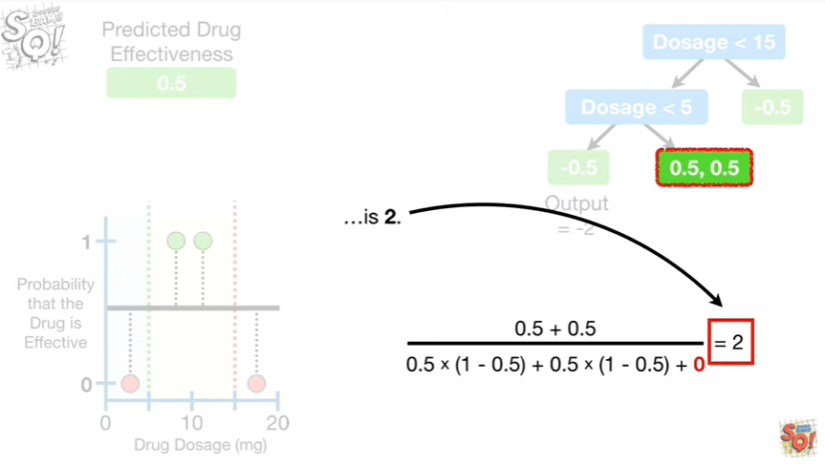

is 2.

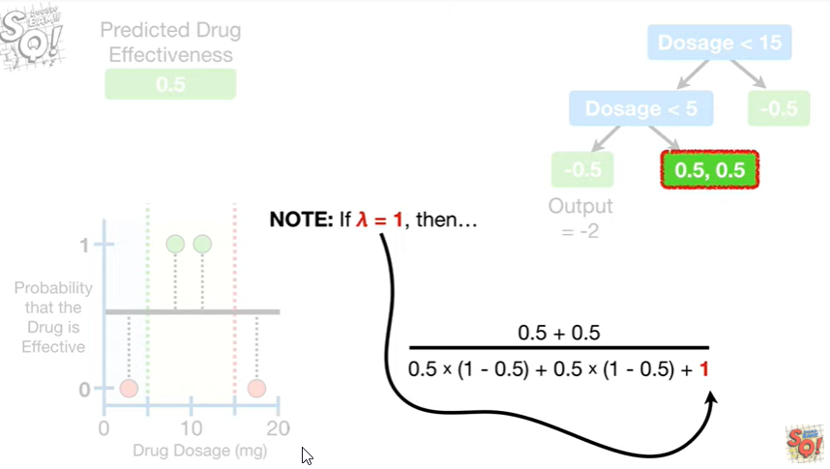

Note : if lambda equals one then

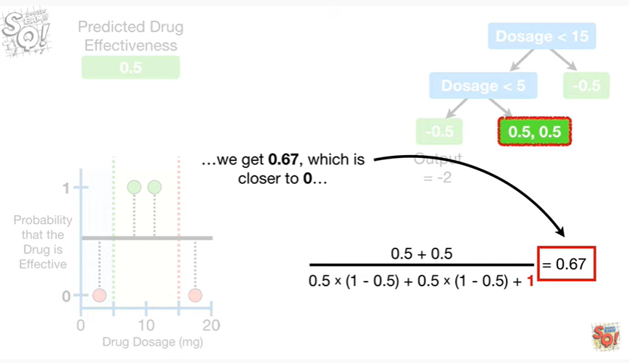

we get 0.67, which is closer to zero

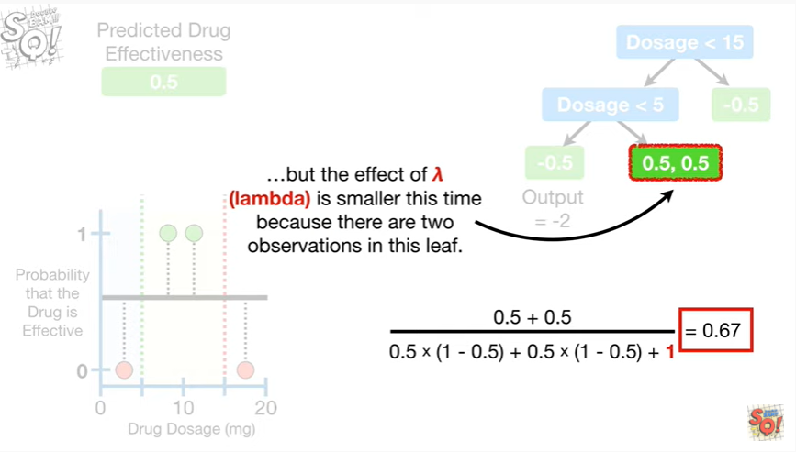

but the effect of lambda is smaller this time because there are two observations in this leaf.

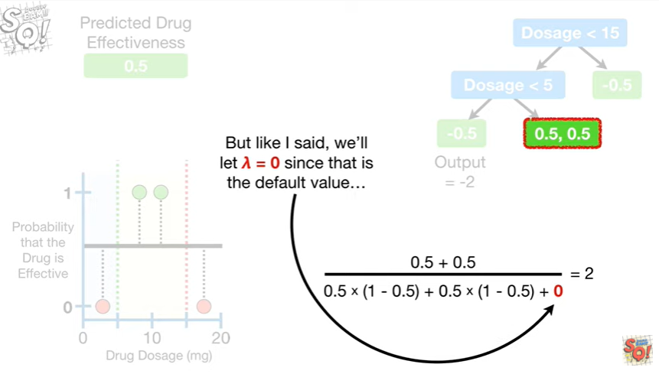

But like I said we'll let lambda equal zero since that is the default value

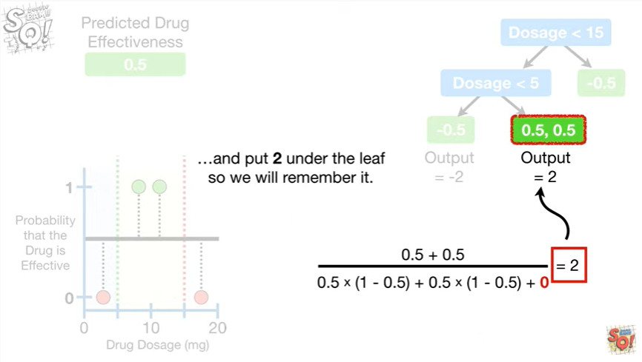

and put two under the leaf so we will remember it.

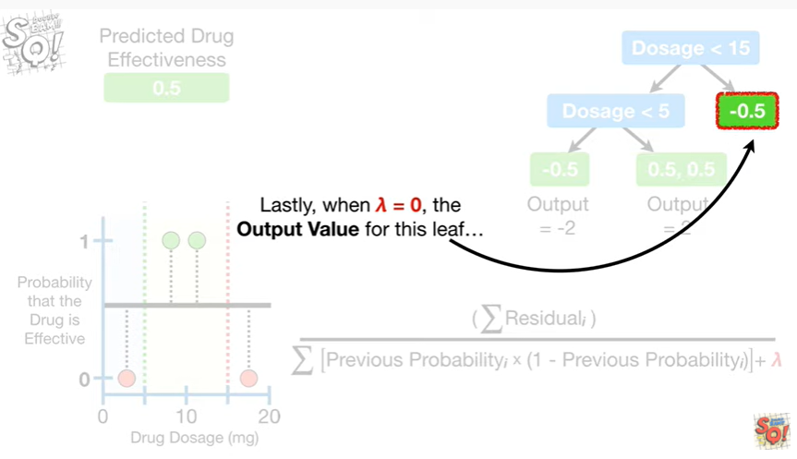

Lastly, when lambda equals zero the output value for this leaf

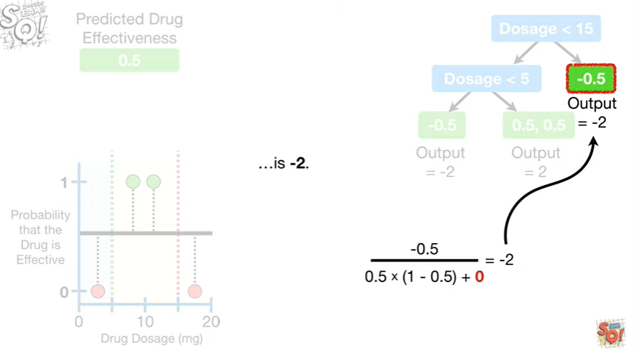

is negative two.

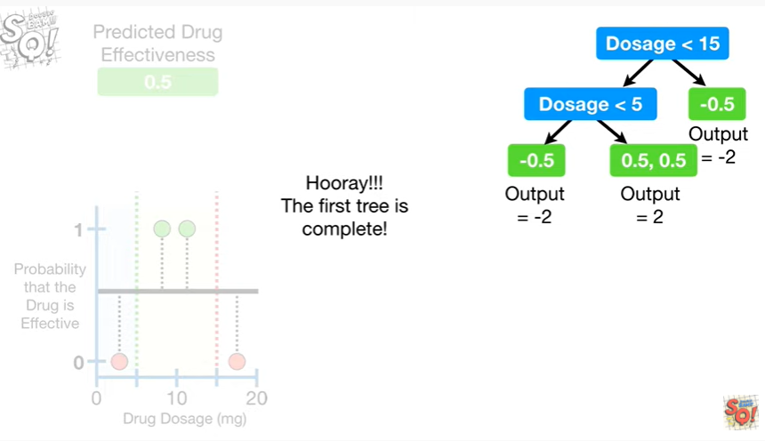

Hooray !!!

The first tree is complete !

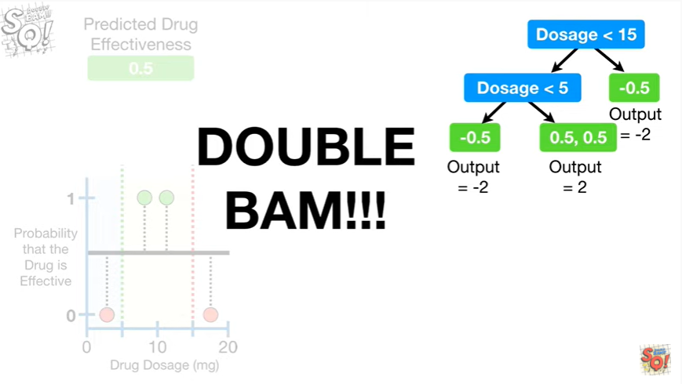

Double BAM !!!

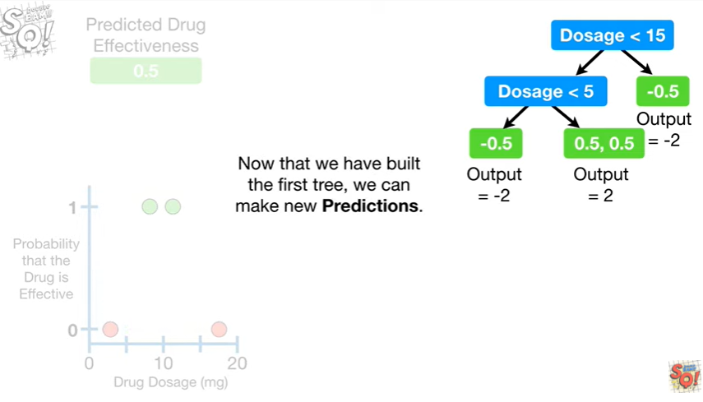

Now that we have built the first tree, we can make new predictions.

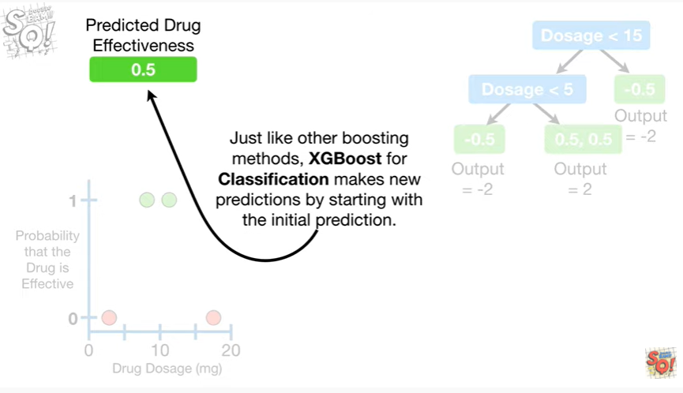

Just like other boosting methods, XGBoost makes new predictions by starting with the initial prediction.

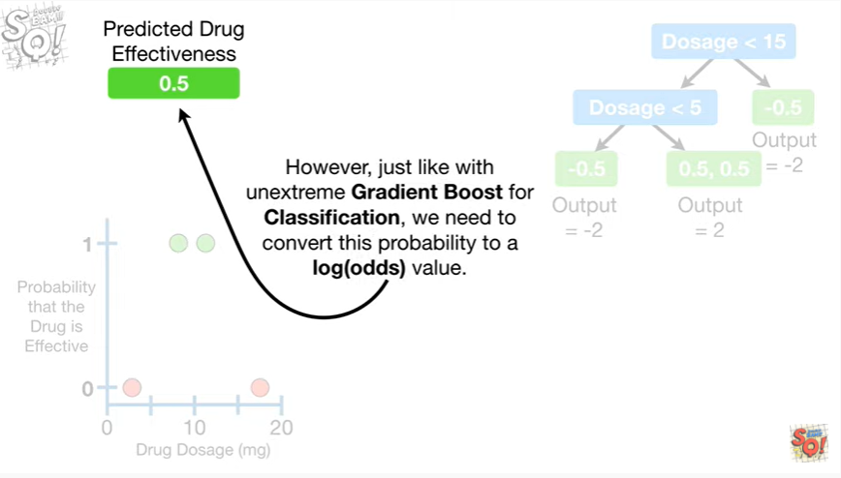

However just like with unextrem gradient boost for classification, we need to convert this probability to a log odds value.

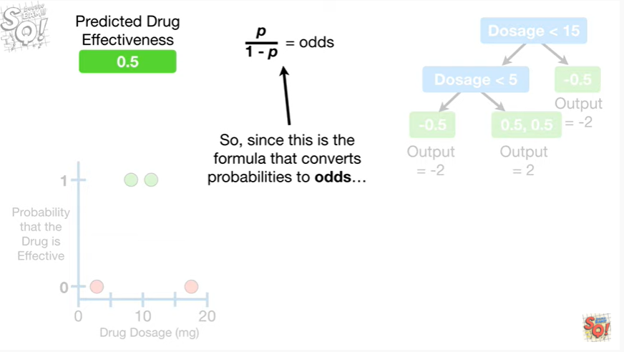

So since this is the formula that converts probabilities to odds

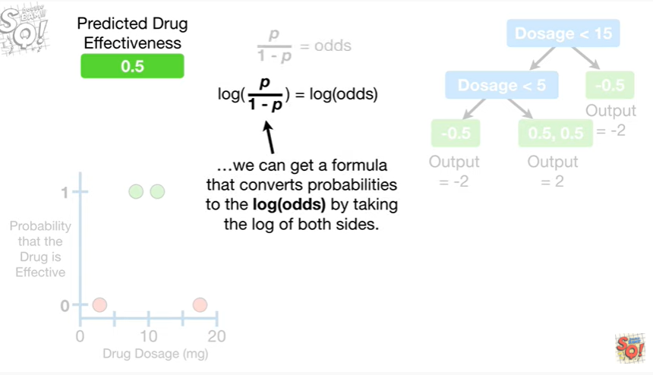

we can get a formula that converts probabilities to the log odds by taking the log of both sides.

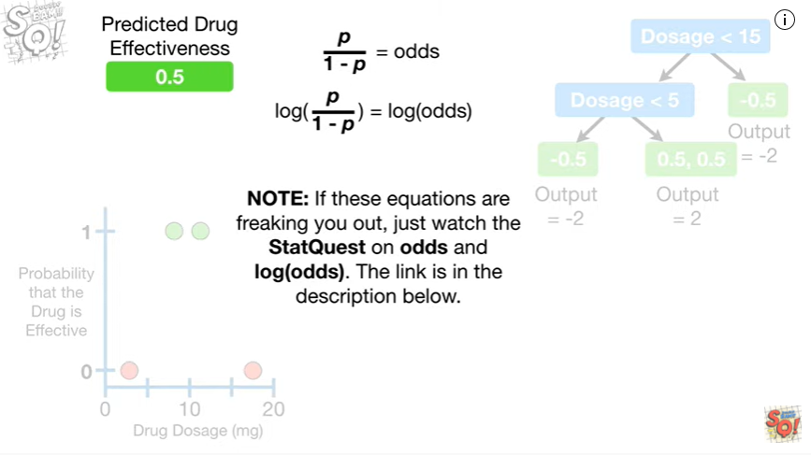

Note : if these equations are freaking you out, just watch the stat quest on odds and log odds.

The link is in the description below.

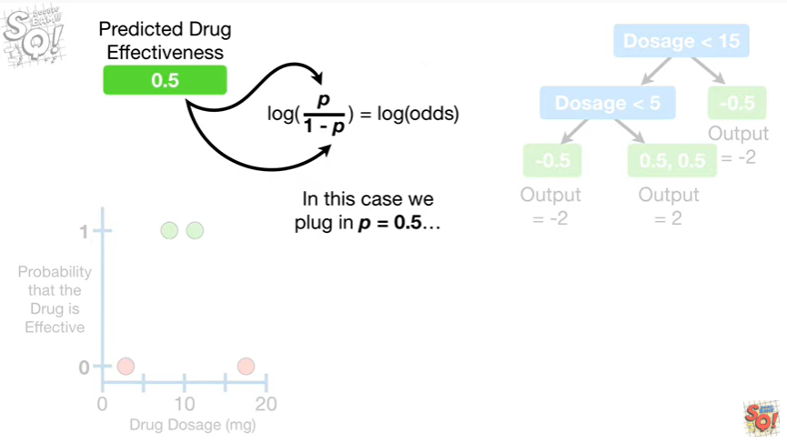

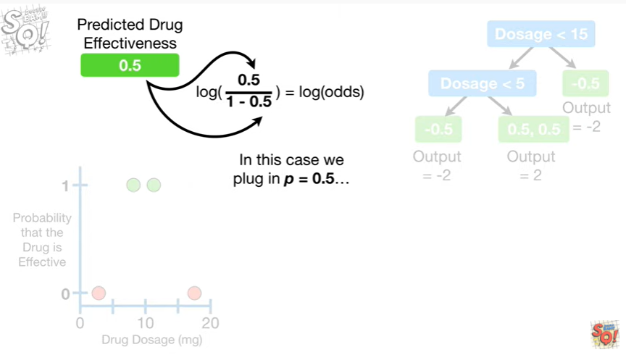

In this case, we plug in P equals 0.5

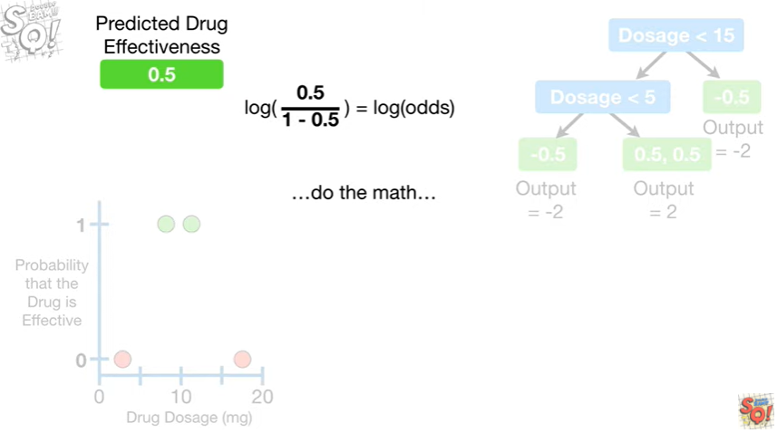

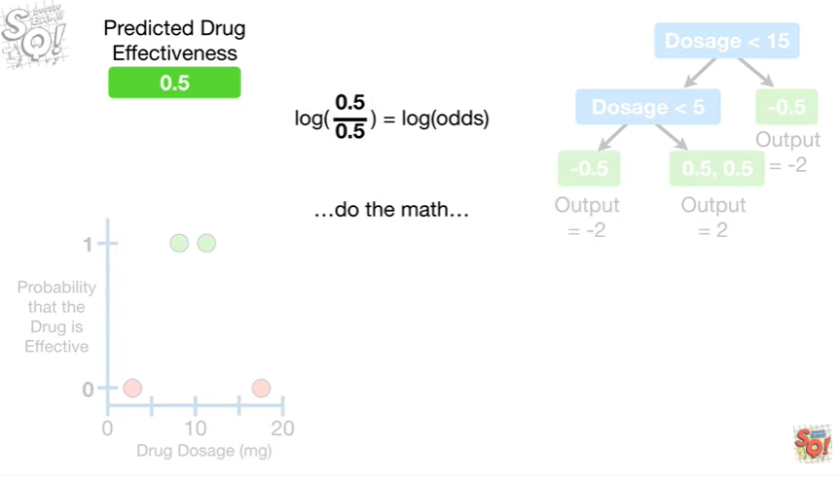

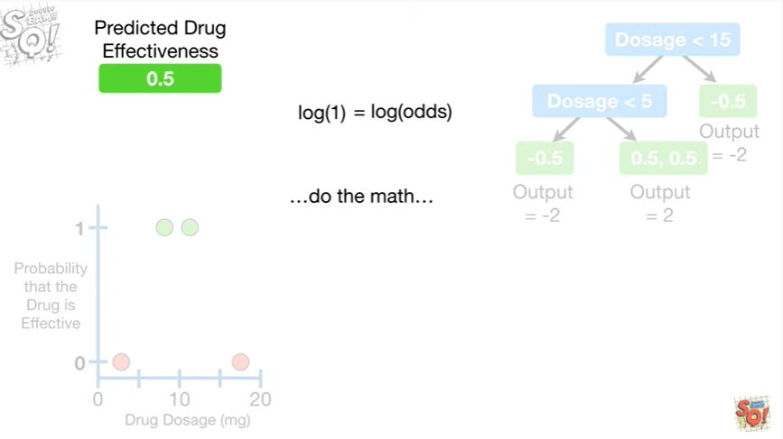

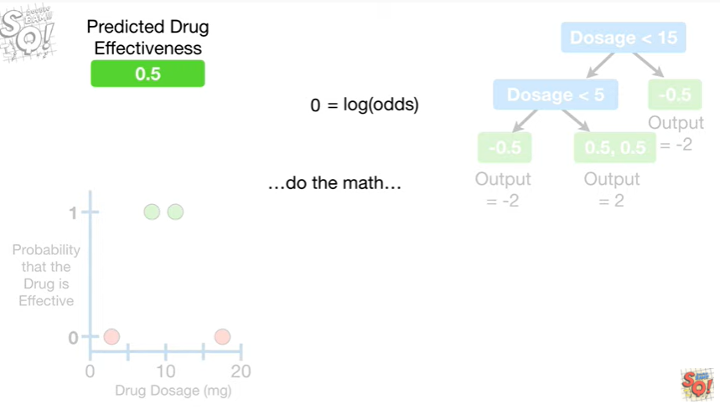

do the math

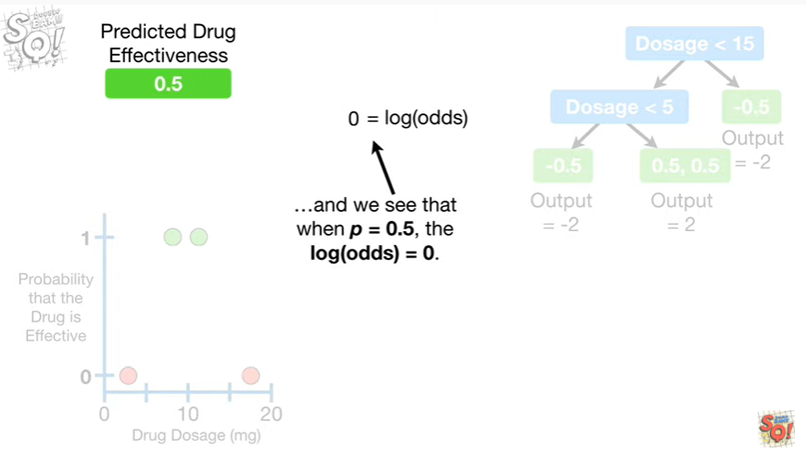

and we see that when P equals 0.5, the log of the odds equals zero.

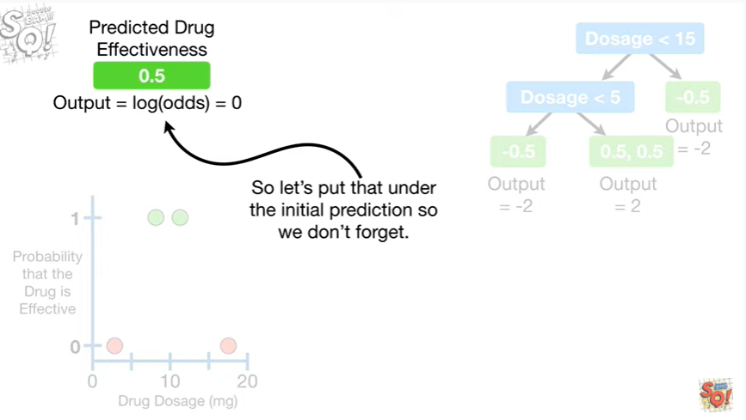

So let's put that under the initial prediction so we don't forget.

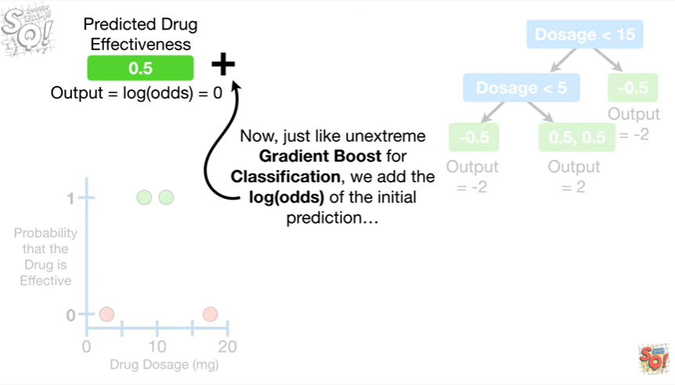

Now, just like unextrem gradient boost for classification, we add the log odds of the initial prediction

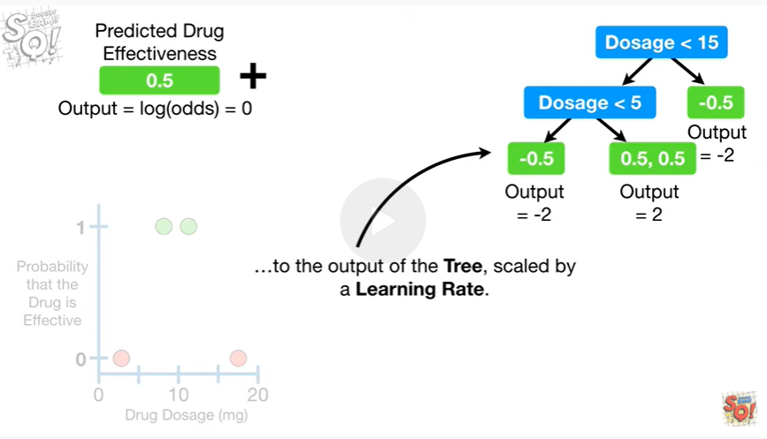

to the output of the tree,

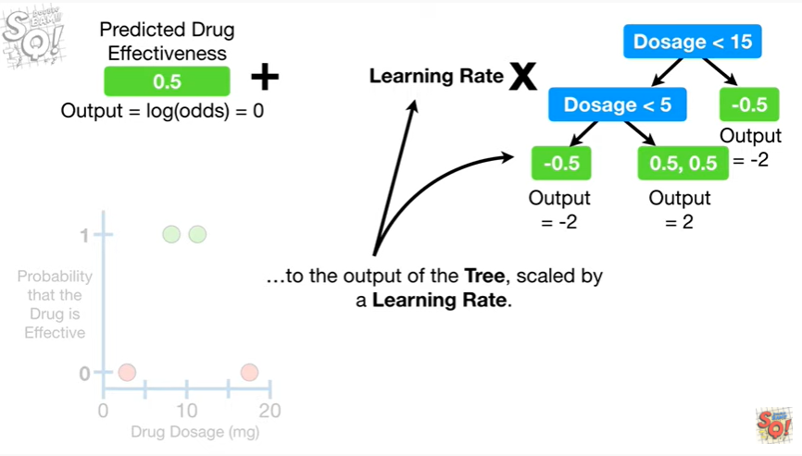

scaled by a learning rate.

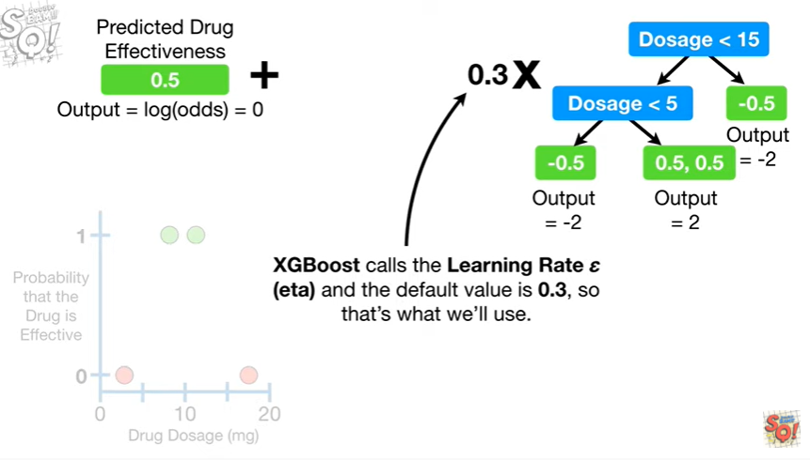

XGBoost calls the learning rate, Eta, and the default value is 0.3, so that's what we'll use.

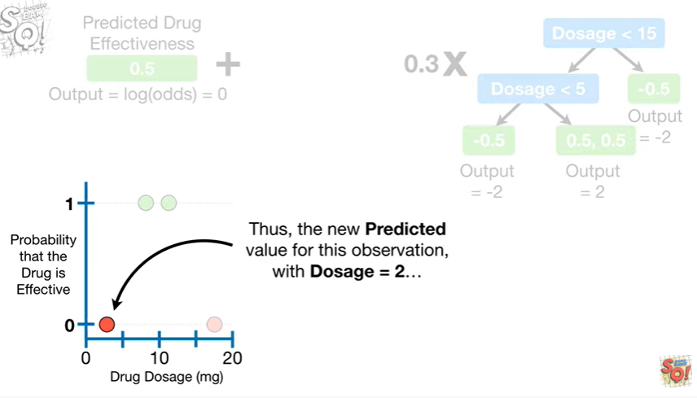

Thus, the new predicted value for this observation with dosage equal 2

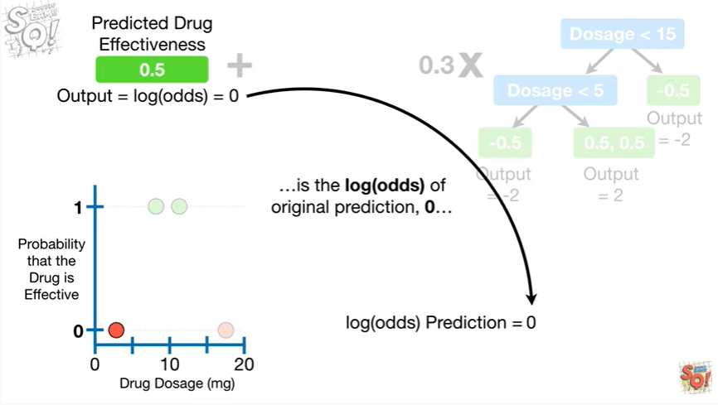

is the log of the odds for the original prediction 0

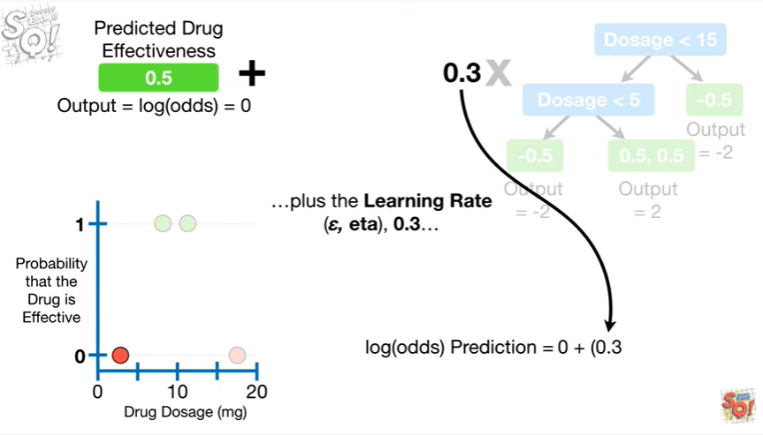

plus the learning rate 0.3

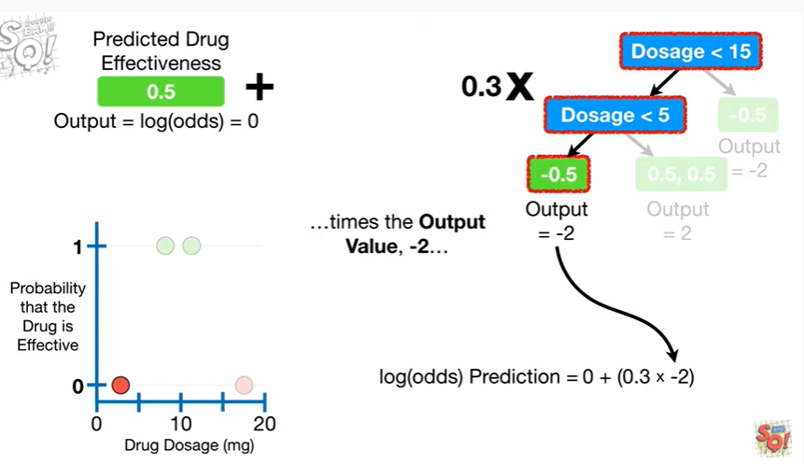

times the output value negative 2

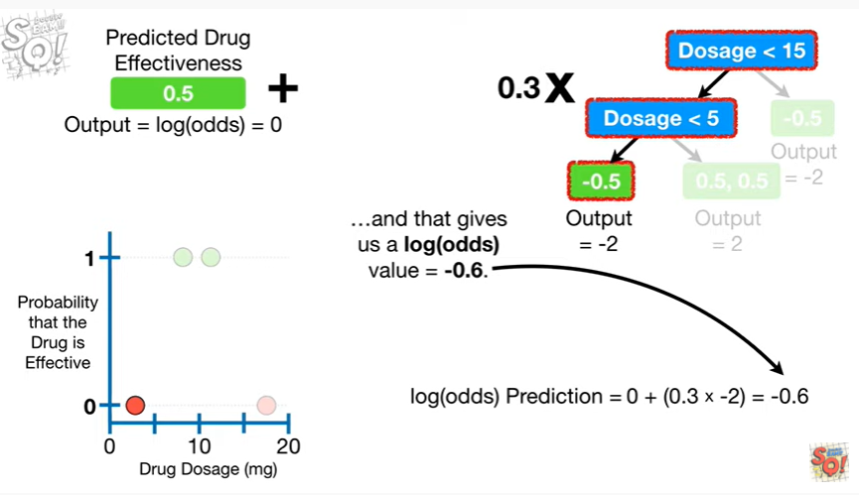

and that gives us a log of the odds value equal to negative 0.6.

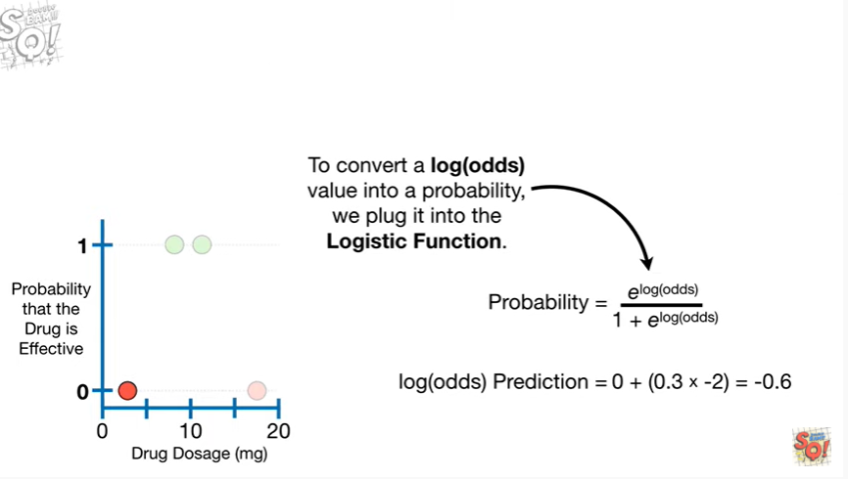

To convert a log of the odds value into a probability, we plug it into the logistic function.

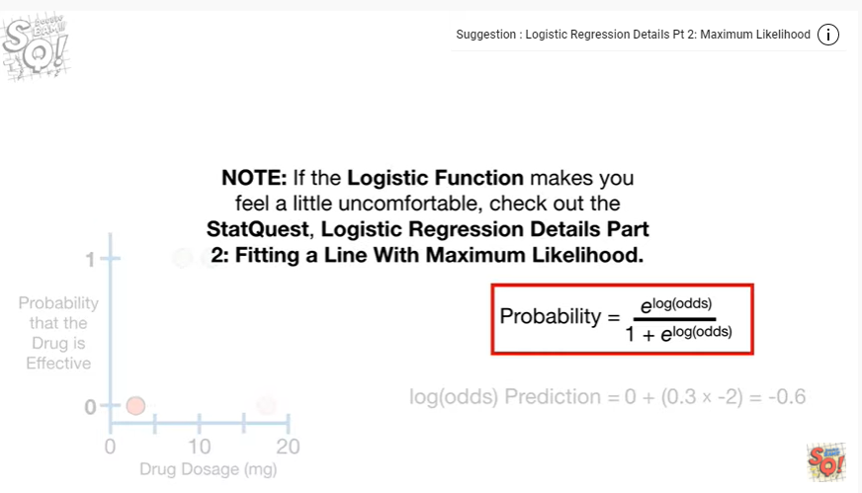

Note : if the logistic function makes you feel a little uncomfortable, check out the stat quest logistic regression details part 2, fitting a line with maximum likelihood.

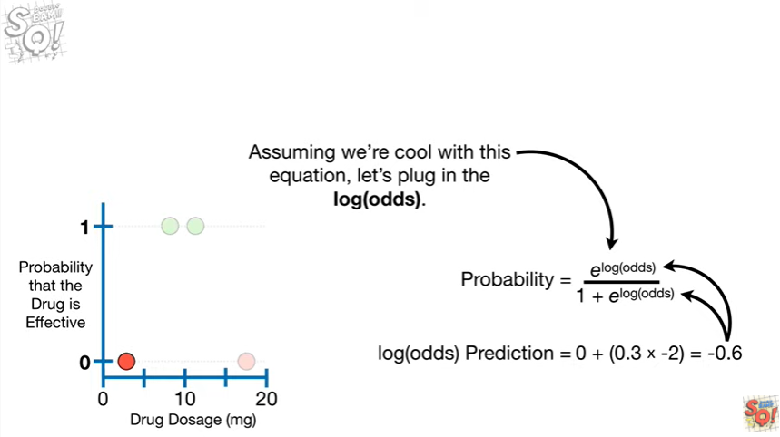

Assuming we're cool with this equation,

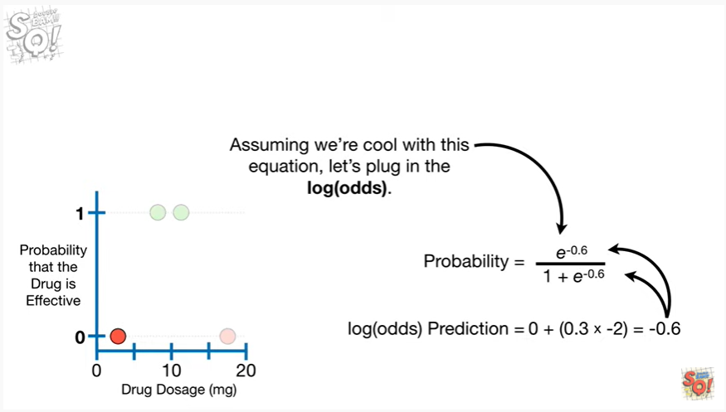

let's plug in the log of the odds

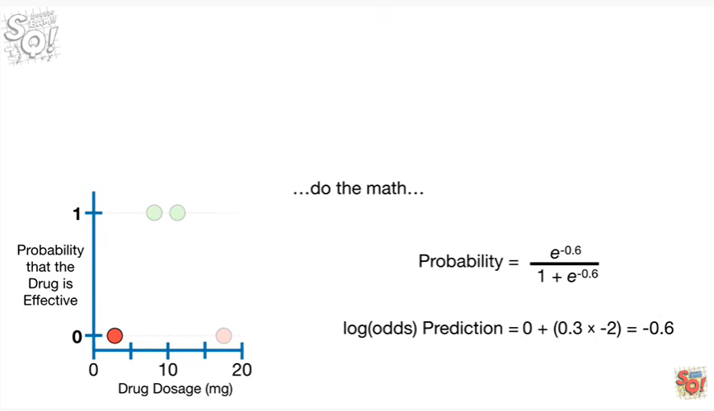

do the math

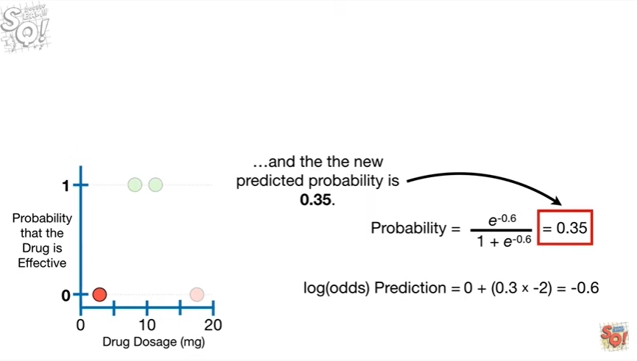

and the new predicted probability is 0.35.

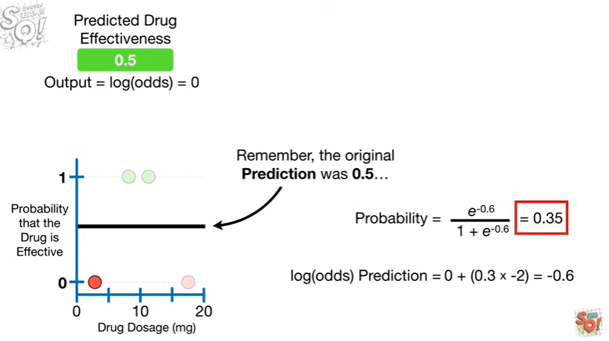

Remember, the original prediction was 0.5

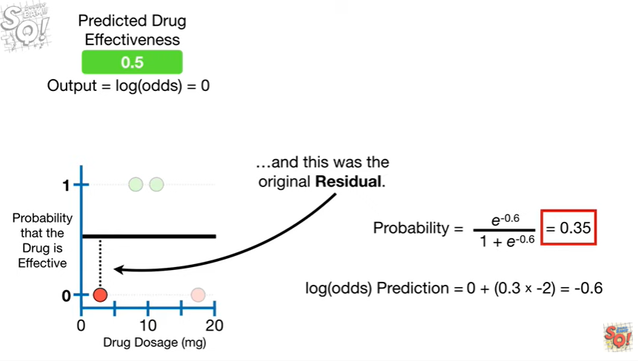

and this was the original residual.

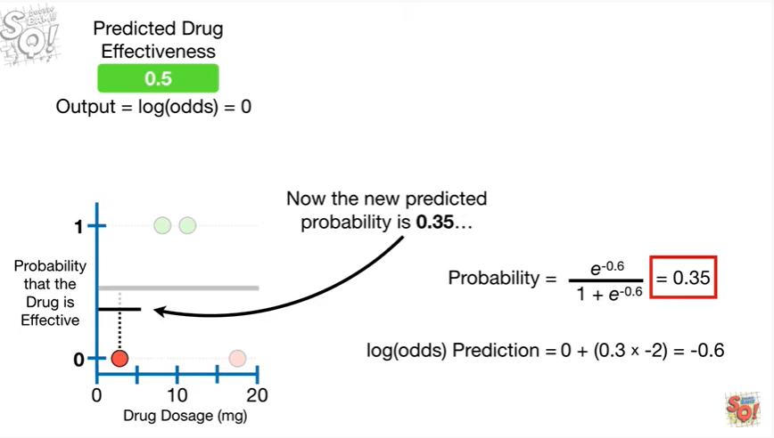

Now the new predicted probability is 0.35

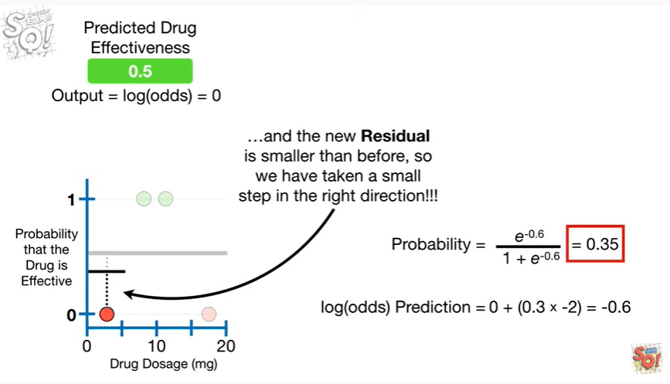

and the new residual is smaller than before, so we have taken a small step in the right direction !!!

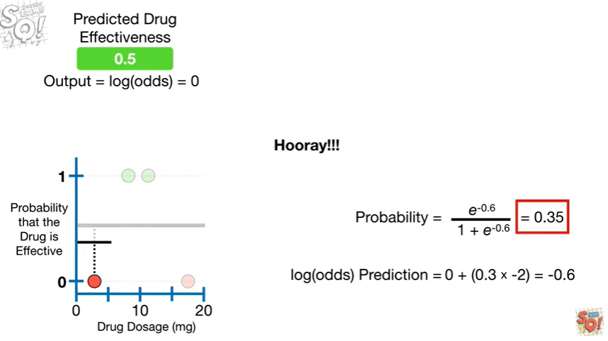

Hooray !!!

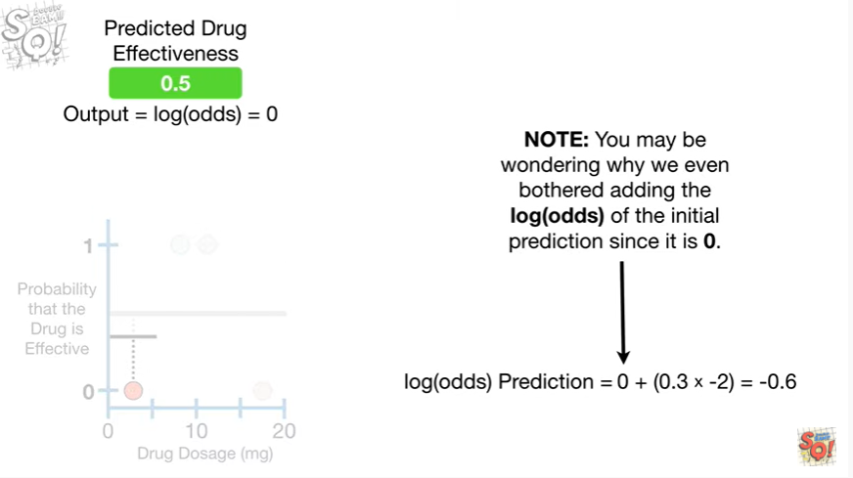

Note : you may be wondering why we even bothered adding the log of the odds of the initial prediction since it is zero.

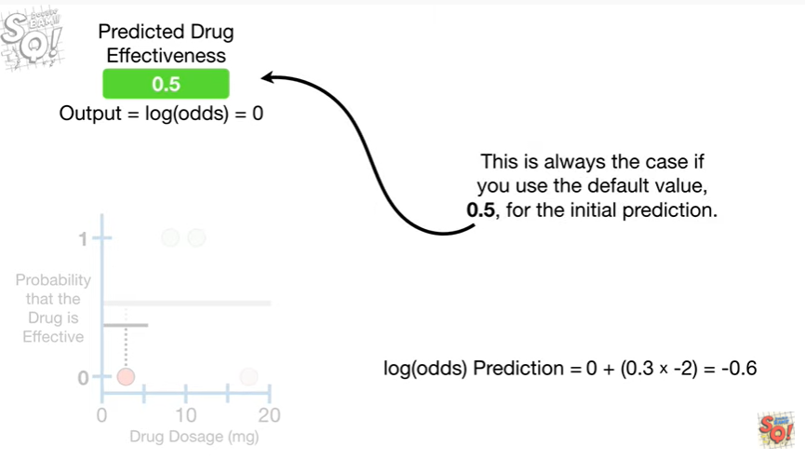

This is always the case if you use the default value 0.5, for the initial prediction.

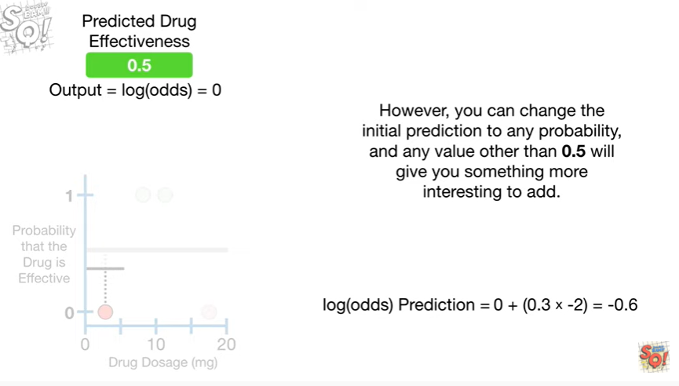

However, you can change the initial prediction to any probability, and any value other than 0.5 will give you something more interesting to add.

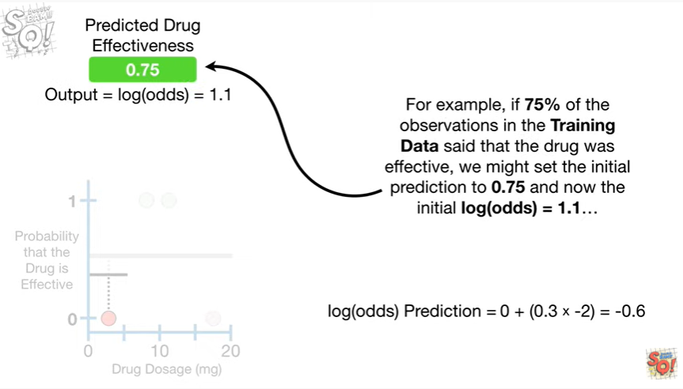

For example if 75% of the observations in the training data said that the drug was effective, we might set the initial prediction to 0.75 and now the initial log of the odds equals 1.1

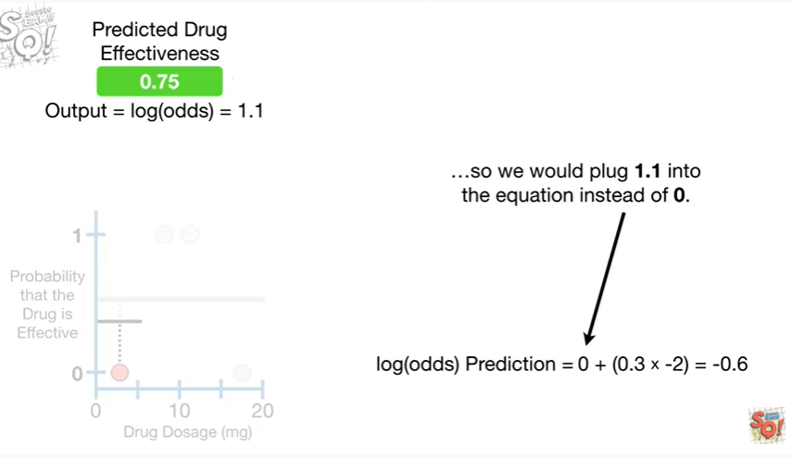

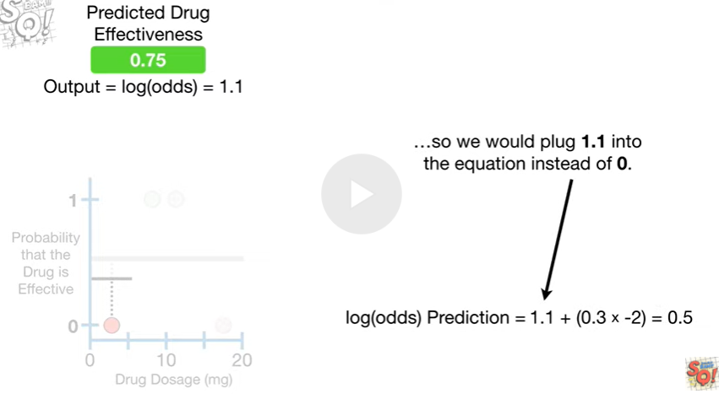

so we would plug 1.1 into the equation instead of 0.

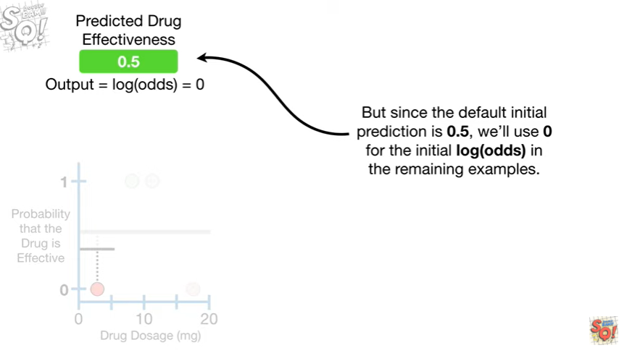

But since the default initial prediction is 0.5 we will use 0 for the initial log of the odds in the remaining examples.

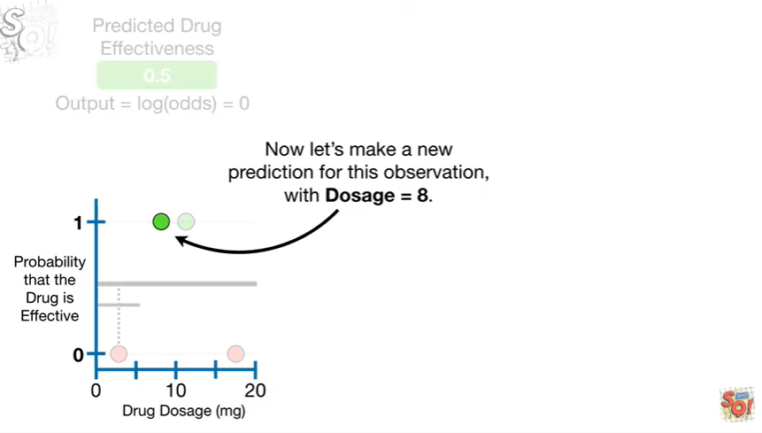

Now let's make a new prediction for this observation with dosage equal to eight.

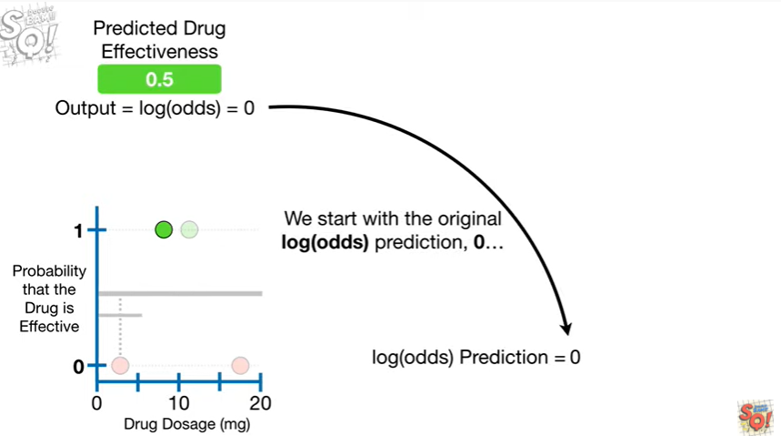

We start with the original log of the odds prediction zero

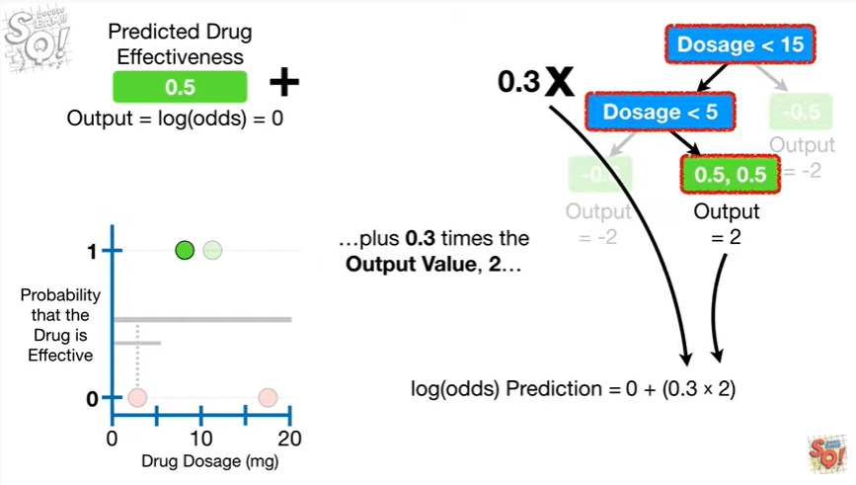

plus zero point three times the output value two

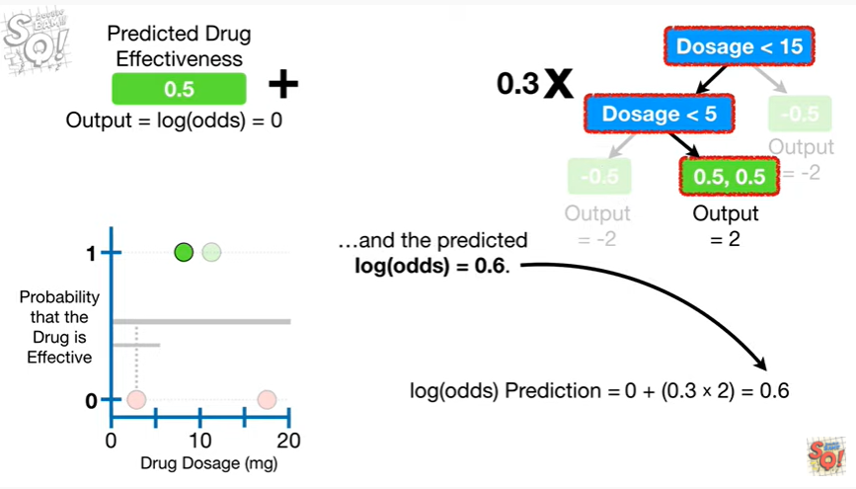

and the predicted log of the odds equals 0.6.

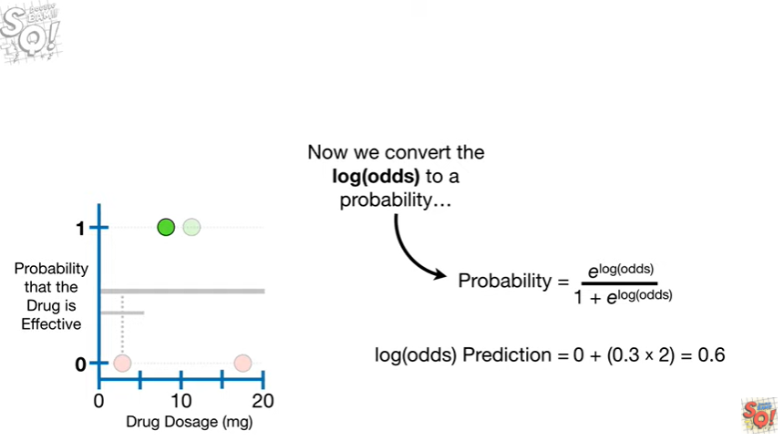

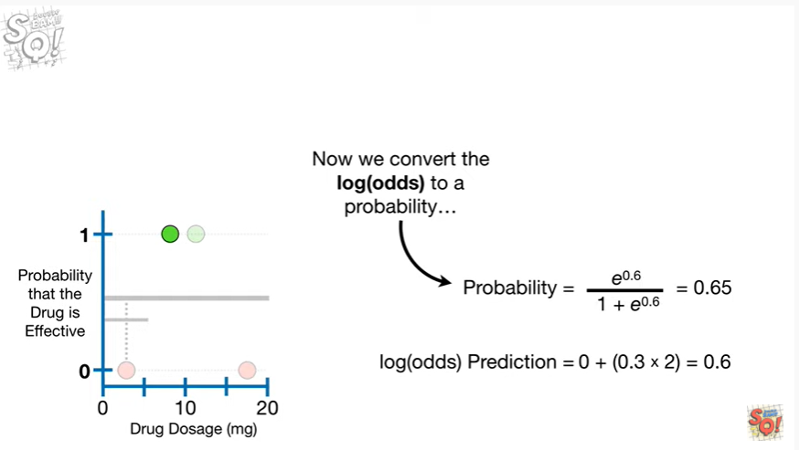

Now we convert the log of the odds to a probability

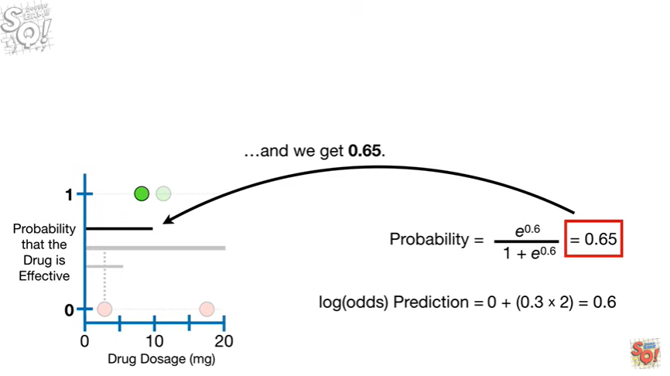

and we get 0.65.

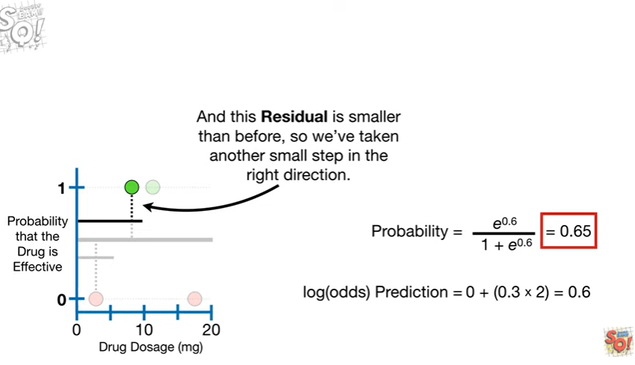

And this residual is smaller than before, so we've taken another small step in the right direction.

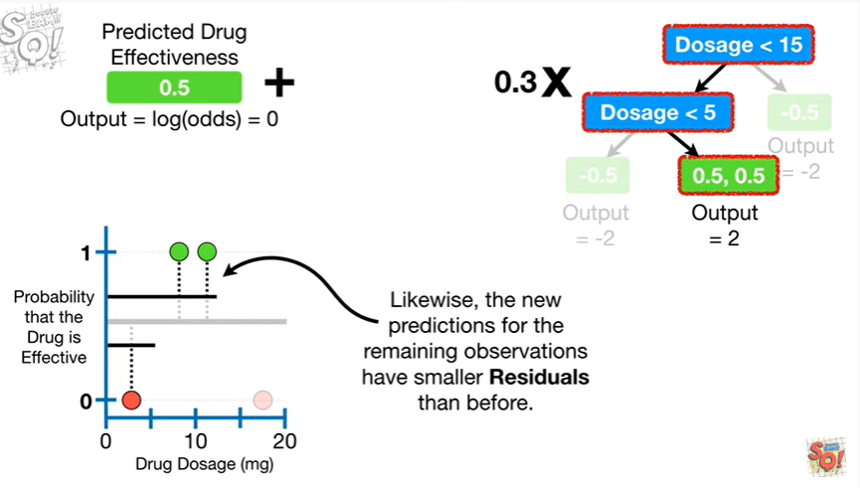

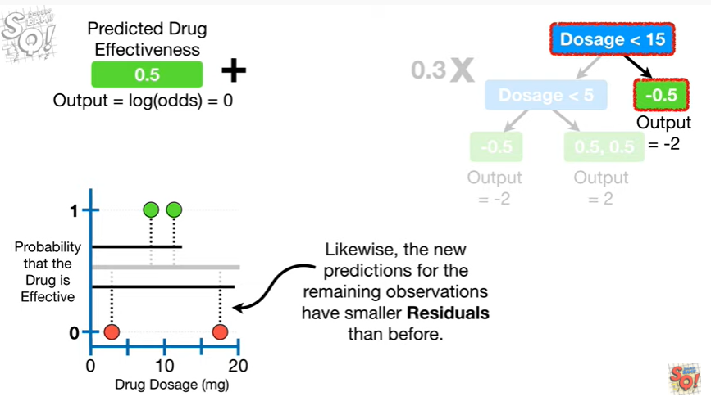

Likewise, the new predictions for the remaining observations have smaller residuals than before.

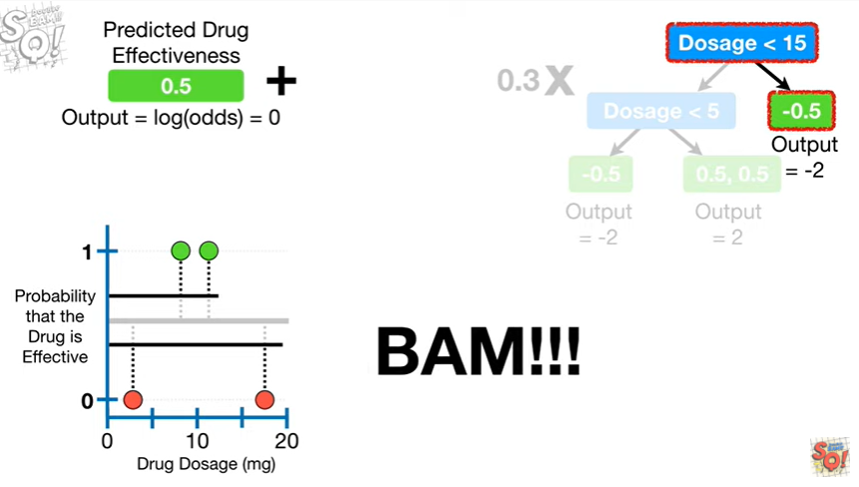

BAM !!

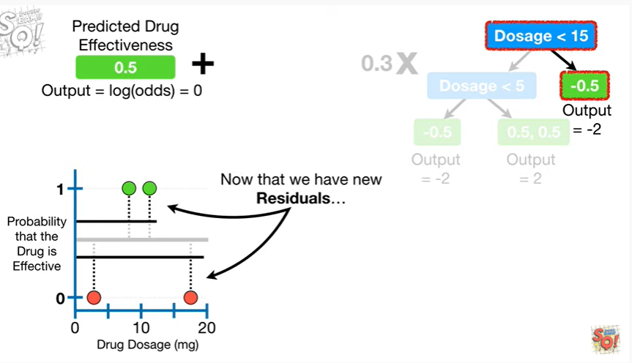

Now that we have new residuals

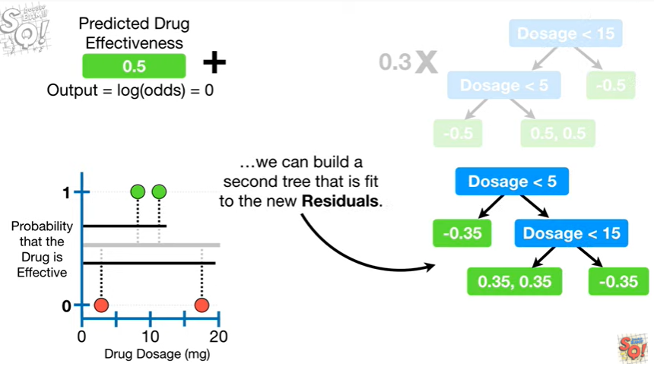

we can build a second tree that is fit to the new residuals.

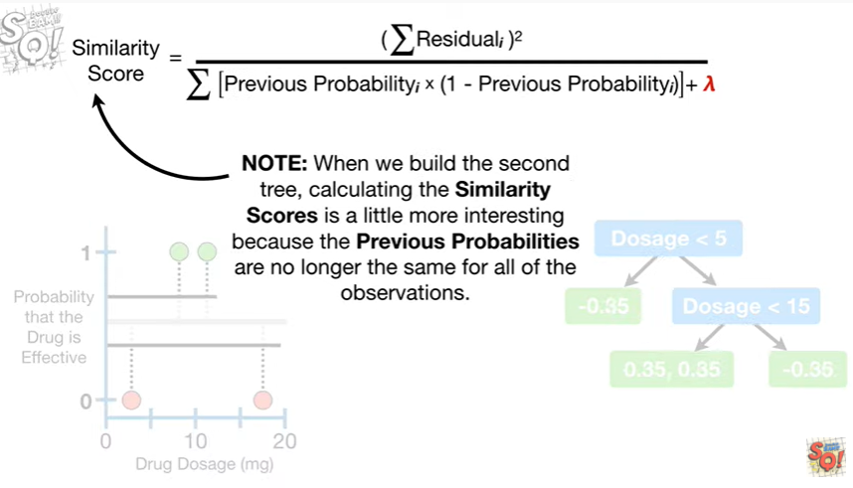

Note : when we build the second tree calculating the similarity scores is a little more interesting because the previous probabilities are no longer the same for all of the observations.

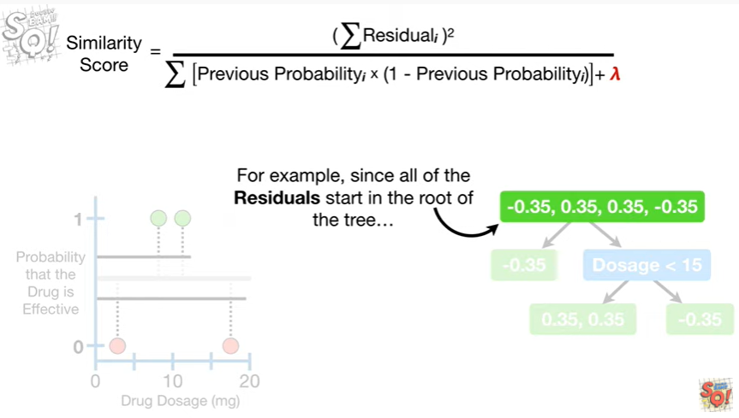

For example since all of the residuals start in the root of the tree

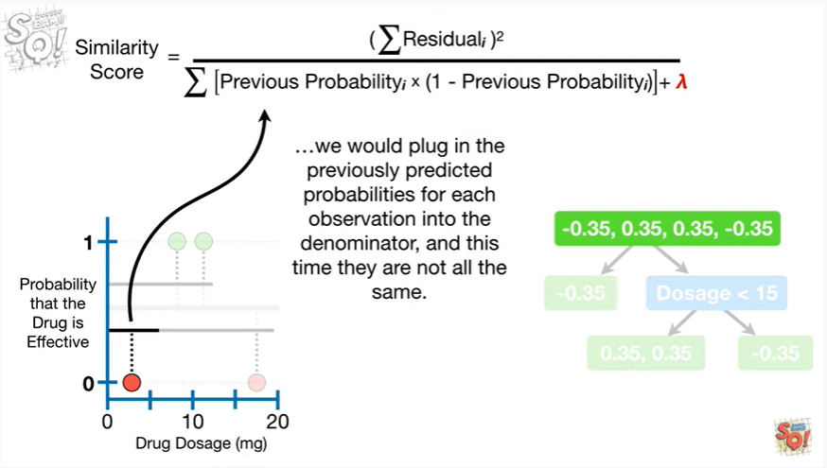

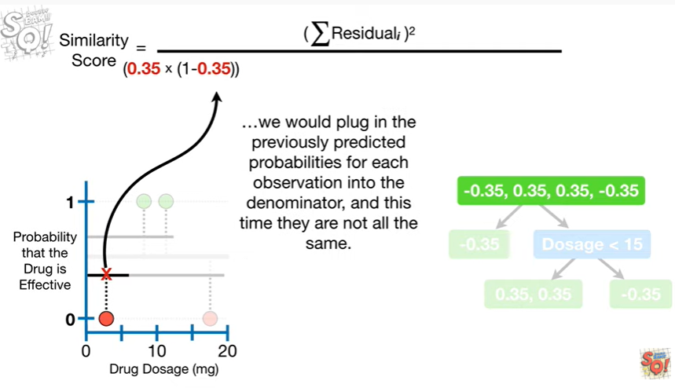

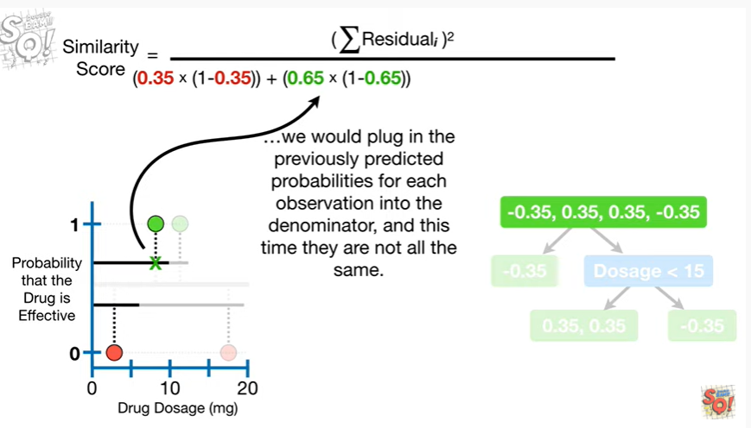

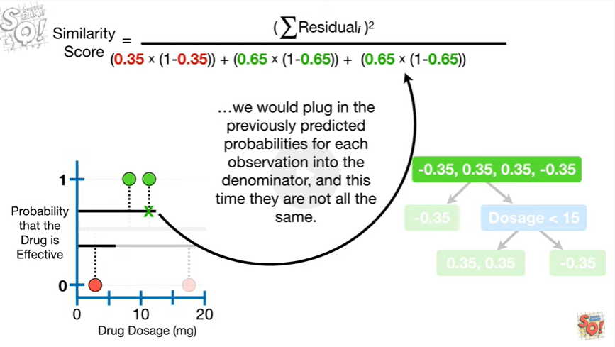

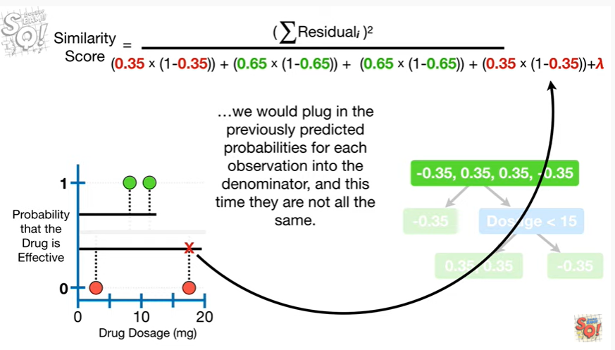

we would plug in the previously predicted probabilities for each observation into the denominator and this time they are not all the same.

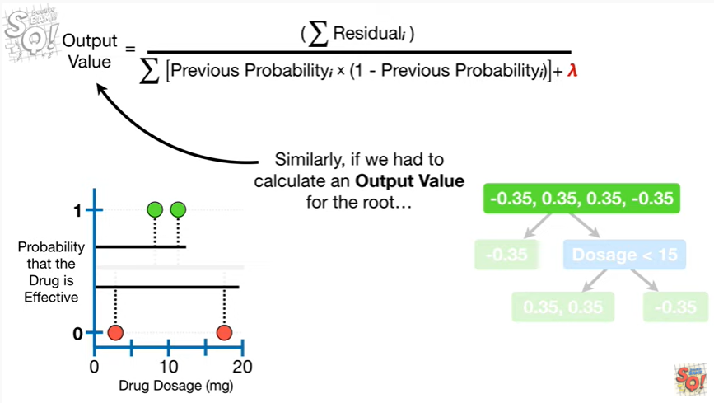

Similarly, if we had to calculate an output value for the root

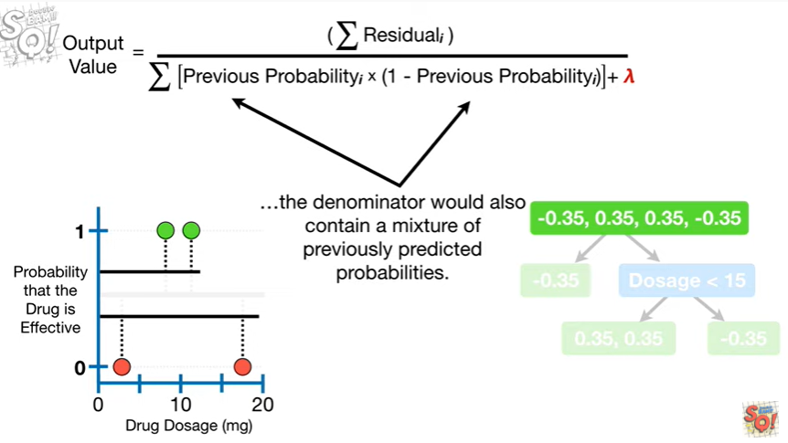

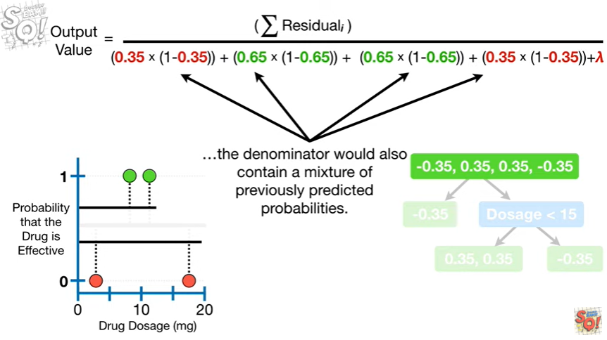

the denominator would also contain a mixture of previously predicted probabilities.

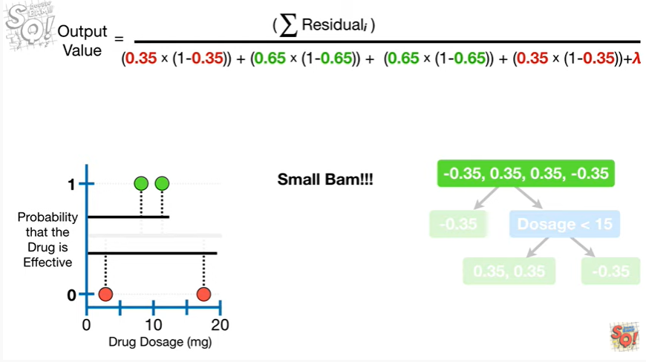

Small BAM !

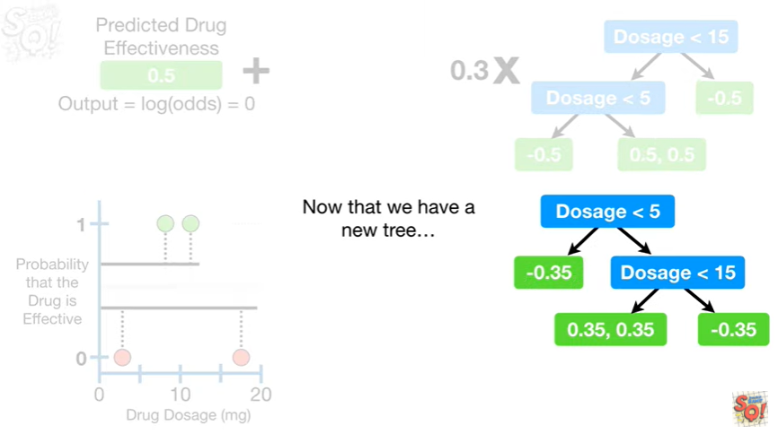

Now that we have a new tree

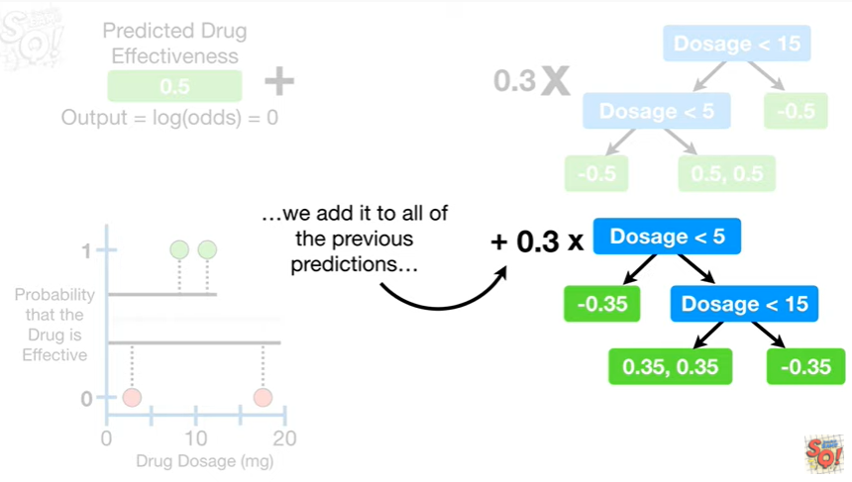

we add it to all of the previous predictions

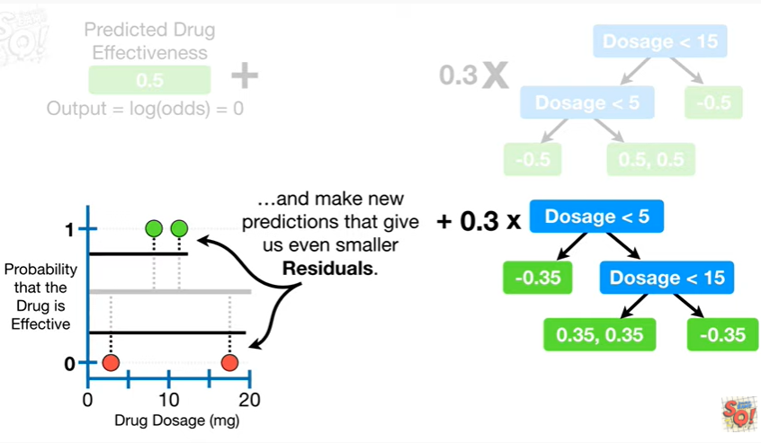

and make new predictions that give us even smaller residuals.

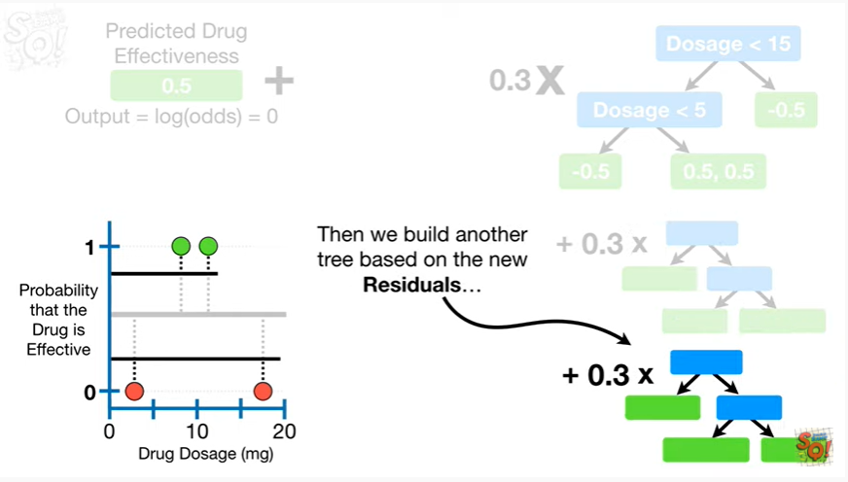

Then we build another tree based on the new residuals

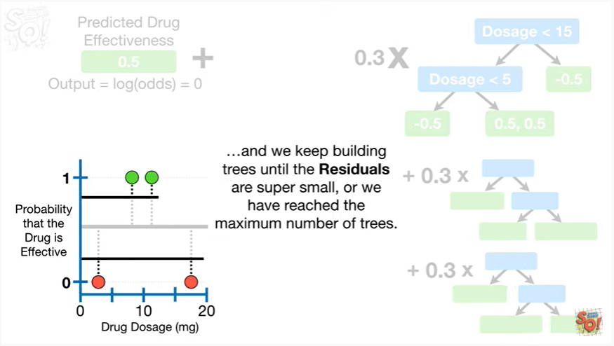

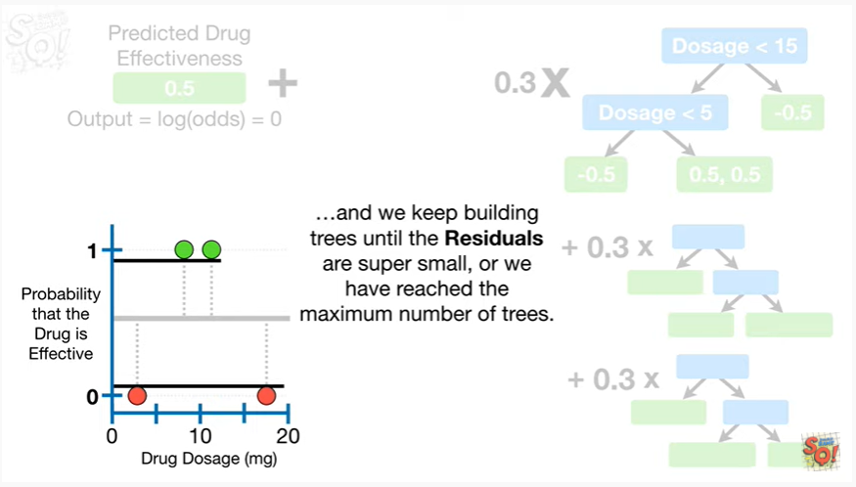

and we keep building trees until the residuals are super small or we have reached the maximum number of trees.

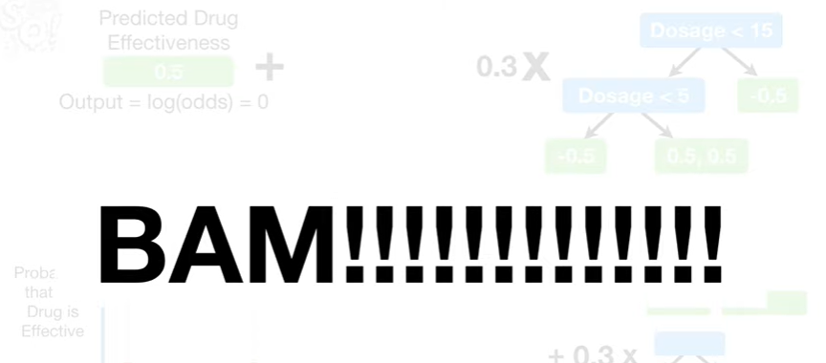

Triple bam !!!



In summary, when building XGBoost trees for classification

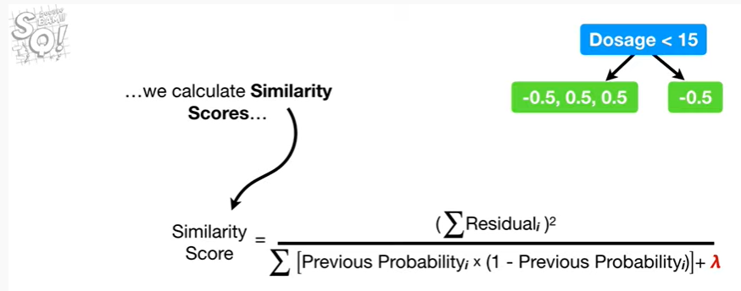

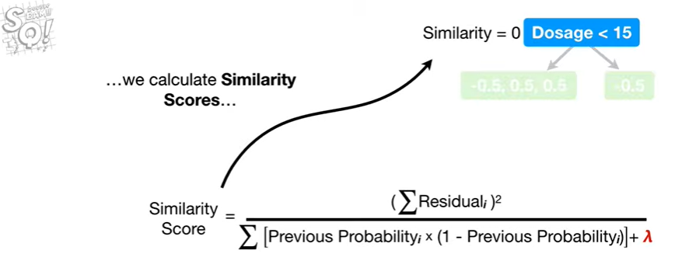

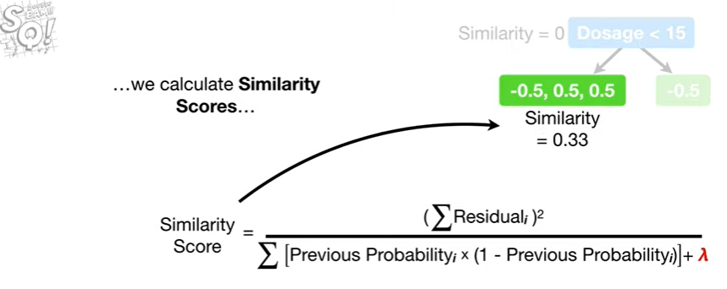

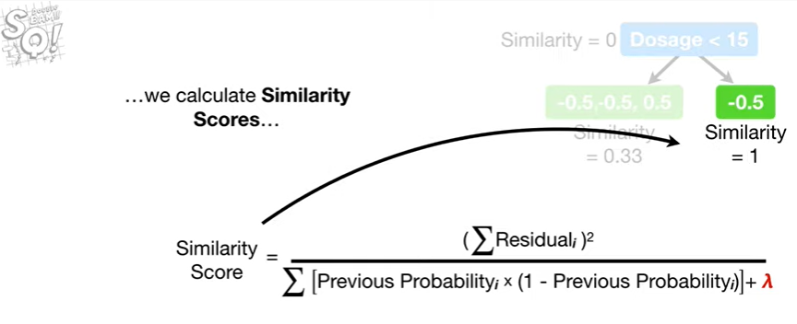

we calculate similarity scores

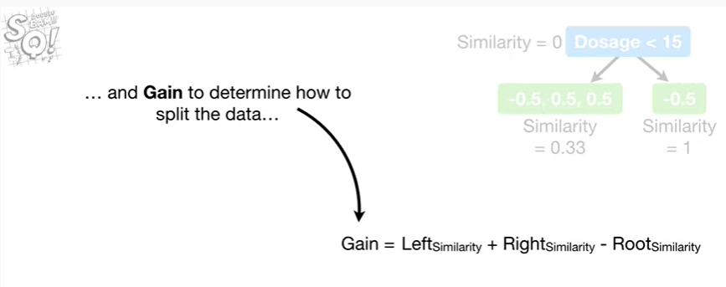

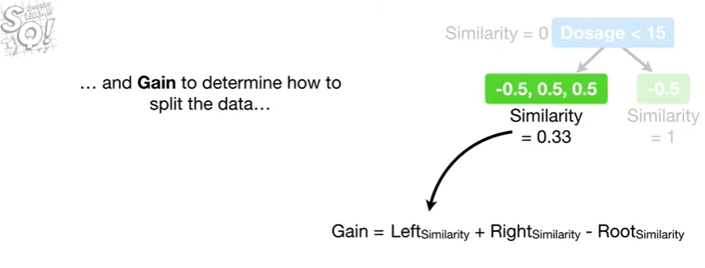

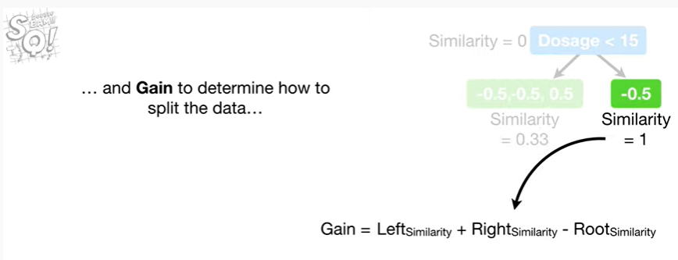

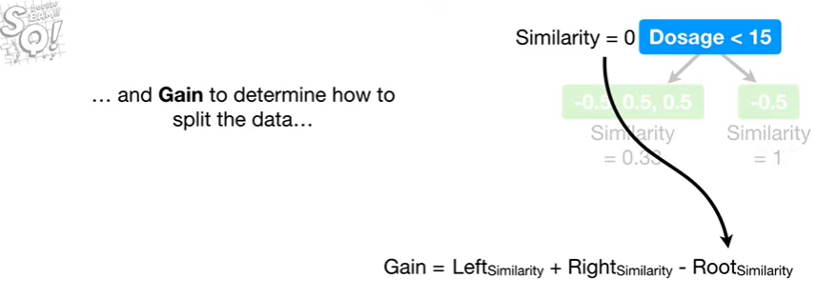

and gain to determine how to split the data

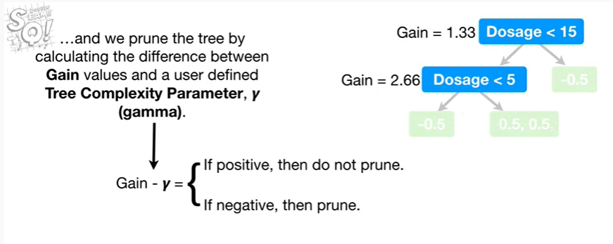

and we prune the tree by calculating the difference between gain values and a user-defined tree complexity parameter gamma.

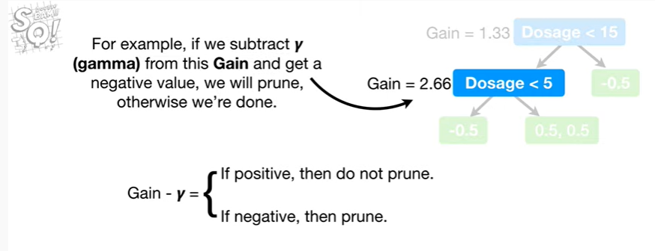

For example, if we subtract gamma from this game and get a negative value, we will prune, otherwise we're done.

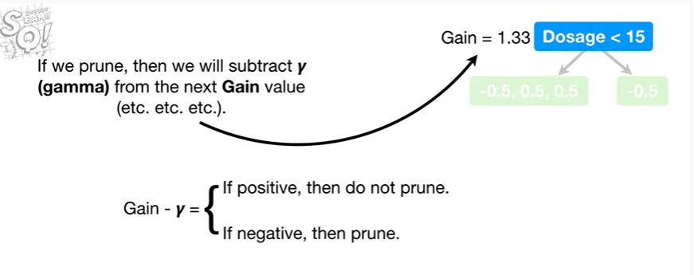

If we prune then we will subtract gamma from the next gain value etc etc etc.

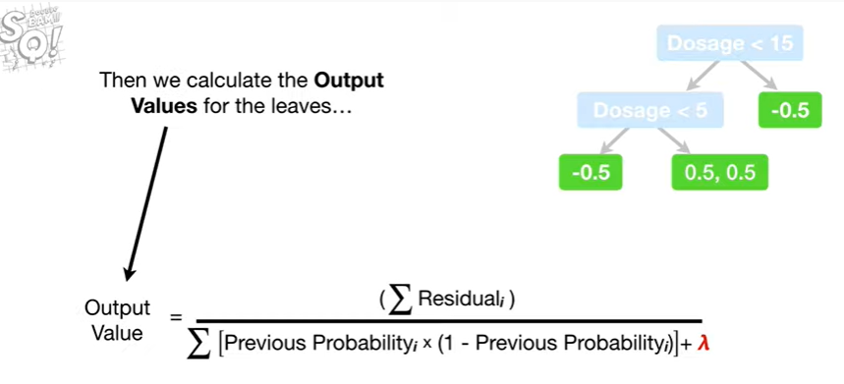

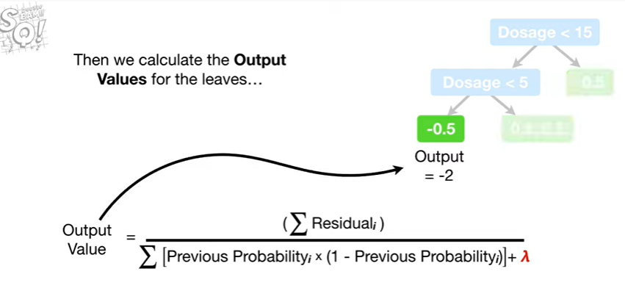

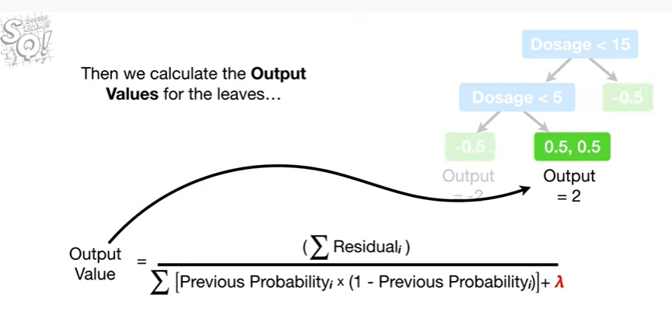

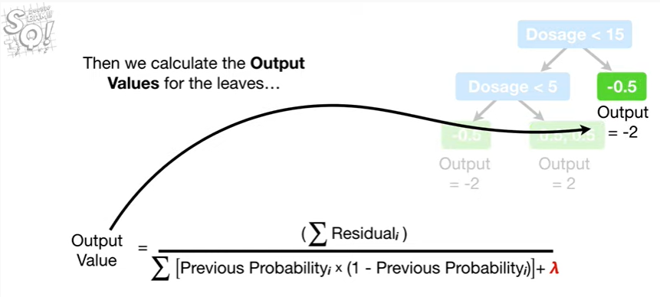

Then we calculate the output values for the leaves

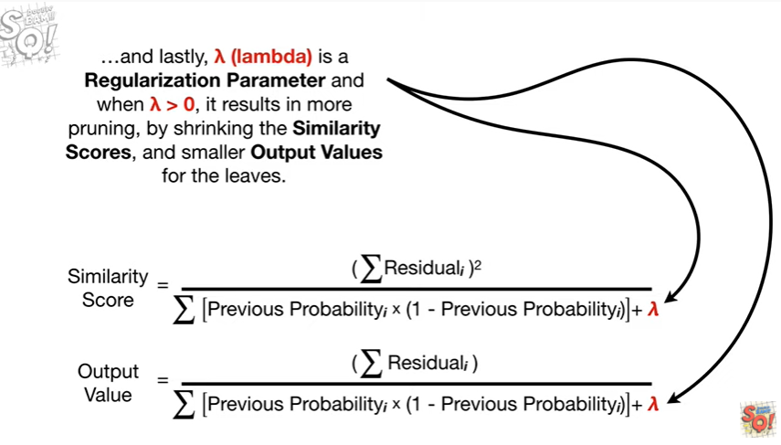

and lastly, lambda is a regularization parameter and when lambda is greater than zero, it results in more pruning by shrinking the similarity scores, and smaller output values for the leaves.

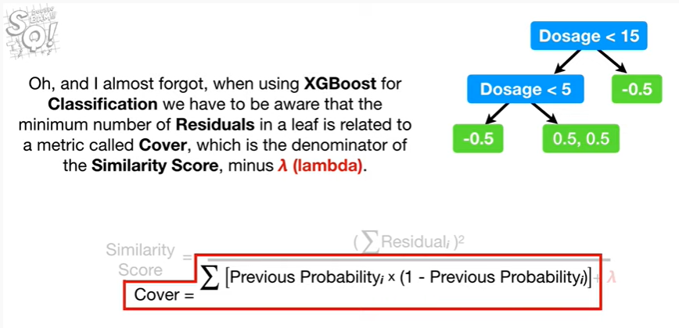

Oh and I almost forgot, when using XGBoost for classification we have to be aware that the minimum number of residuals in a leaf is related to a metric called cover, which is the denominator of the similarity score, minus lambda.

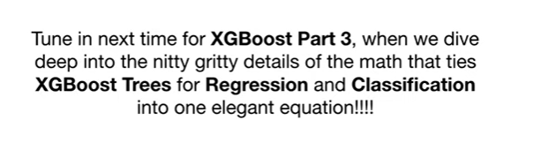

Tune in next time for XGBoost part 3, when we dive deep into the nitty gritty details of the math that ties XGBoost trees for regression and classification into one elegant equation !!!